The EMISSARY
Sister Silence as Sacrament
By Marilynn Hughes
An Out-of-Body Travel Book
The Out-of-Body Travel Foundation!
http://outofbodytravel.org



The EMISSARY
Sister Silence as Sacrament
By Marilynn Hughes
An Out-of-Body Travel Book
The Out-of-Body Travel Foundation!
http://outofbodytravel.org

Copyright 2014, Marilynn Hughes
All rights reserved, including the right to reproduce this work or portions thereof in any form whatsoever without permission in writing from the publisher and author, except for brief passages in connection with a review.
All credits for quotations are included in the Bibliography.
For information, write to:
The Out-of-Body Travel Foundation!
http://outofbodytravel.org
MarilynnHughes@outofbodytravel.org
If this book is unavailable from your local bookseller, it may be obtained directly from the Out-of-Body Travel Foundation by going to www.outofbodytravel.org.
Having worked primarily in radio broadcasting, Marilynn Hughes spent several years as a news reporter, producer and anchor before deciding to stay at home with her three children. She's experienced, researched, written, and taught about out-of-body travel since 1987.

Books by Marilynn Hughes:

Come to Wisdom's Door
How to Have an Out-of-Body Experience!

Out-of-Body Experiences
What you Need to know

The Hammer of Mysticism
Encylopedic Journey into Mystical Processes and Terms
The Fragrance of the Mystical Rose
The Revelation of the Celestial Mysteries from the Enclosed Garden of God

The Mysteries of the Redemption
A Treatise on Out-of-Body Travel and Mysticism

The Mysteries of the Redemption Series in Five Volumes
(Same Book - Choose Your Format!)
Prelude to a Dream
Passage to the Ancient
Medicine Woman Within a Dream
Absolute Dissolution of Body and Mind
The Mystical Jesus

The Mysteries of the Redemption
Prayer Book

The Mysteries of the Redemption
Devotional

GALACTICA
A Treatise on Death, Dying and the Afterlife

THE PALACE OF ANCIENT KNOWLEDGE
A Treatise on Ancient Mysteries

Touched by the Nails
(Watch and Wait)
A Karmic Journey Revealed!
Principles of THE WORLD BEYOND Death
Books of Terror
Evil Exists, it's Closer than you Think
Based on the Visions of Mary Hughes
By Marilynn Hughes

Evergreen
The Autobiography of a mystic

The Mystical Captive
The Mystical Freeborn
The Royal Question
The Solitary
In my Aloneness, I Feel the Wind.
It has Consciousness, it has Breath.
And it Speaks.
The EMISSARY
Sister Silence as Sacrament

Michael Jackson:
The Afterlife Experiences
A Theology of Michael Jackson's Life and Lyrics

Michael Jackson:
The Afterlife Experiences II
Michael Jackson’s American Dream to Heal the World

Michael Jackson:
The Afterlife Experiences III
The Confessions of Michael Jackson

Comparative Religious Mystical Theology
Out-of-Body Travel in World Religion

Forgotten Mystics in World Religions
Lesser Known Out-of-Body Experiences

Selfishness and Self-Will
The Path to Selflessness in World Religions

A Life of Cultivation
Near Death and Out-of-Body Experiences
(Auspicious Births and Deaths)
Of the Prophets, Saints, Mystics and Sages in World Religions
The Voice of the Prophets
Wisdom of the Ages - Volumes 1 - 12
At the Feet of the Masters
Teaching Stories of the Prophets in World Religions
World Religions and their Prophets

Miraculous Images:
Photographs Containing God’s Fingerprints
Suffering:
The Fruits of Utter Desolation
We are all Shadows

The Overview Series
The Oral Transmissions of the 52 Soto Zen Buddhist Ancestors
The Doctors of the Catholic Church
The General Councils of the Catholic Church
Marian Apparitions in the Catholic Church
Heresies in the Catholic Church
Miraculous Phenomena in the Catholic Church
Fascinating Figures in World Religion
Practices, Prayer, Ritual, Liturgy, Sacraments and Theology in the Catholic Church
Writers of the Philokalia
Protestant Reforms
Bridal Mysticism
Mystic Knowledge Series:
Out-of-Body Travel
Ghosts and Lost Souls
Spirit Guides and Guardian Angels
Reincarnation and Karma
Spiritual Warfare, Angels and Demons
Death, Dying and the Afterlife
Heaven, Hell and Purgatory
ExtraTerrestrials
Destiny and Prophecy
Initiations into the Mysteries
Visions of Jesus and the Saints
Ascension
Suffering and Sickness
Mystical Poetry
CHILDREN'S BOOKS
The Former Angel! - A Children’s Tale
(Ages 2 - 8)

The Mystery of the Key to Heaven!
(Ages 2 - 10)
Streams in the Willow
The Story of One Family’s Transformation from Original Sin
Compilations
Out-of-Body Travel and Near Death Experiences: Compiled Works through 2006
World Religions and Ancient Sacred Texts: Compiled Compiled Works through 2006
The Voice of the Prophets:
Abridged Lesser Known Texts

The Mystical Captive Series:
A Trilogy in One Volume

Michael Jackson’s Afterlife Experiences
A Trilogy in One Volume
The Out-of-Body Travel Foundation Journals
Journal One: The Importance of the Seven Virtues and Vices in Understanding the Practice of Out-of-Body Travel!
Journal Two: My Out-of-Body Journey with Sai Baba, Hindu Avatar!
Journal Three: The History of 'The Out-of-Body Travel Foundation!'
Journal Four: A Menage of Wonderful Writers and Artists!
Journal Five: The Stories of Cherokee Elder, Willy Whitefeather!
Journal Six: Discerning your Vocation in Life by Learning the Difference Between Knowledge and Knowing!
Journal Seven: When Tragedy Strikes
Journal Eight: Comparing the Buddhist Avalokiteswara's Descent into Hell with that of Jesus Christ!
Journal Nine: Huzur Maharaj Sawan Singh - Sant Mat (Sikh) Master Guru and Grandson Maharaj Charan Singh - Sant Mat (Sikh) Master Guru
Journal Ten: The Great Beyond
Journal Eleven: Ghosts and Lost Souls: Our Responsibility
Journal Twelve: The 800th Anniversary of Jalalludin Rumi, and the True Spiritual Heritage of Afghanistan and the Middle East
Journal Thirteen: Pensatia – Forgotten Rosicrucian Mystic
Journal Fourteen: Reverend John Macgowan – Forgotten Protestant Mystic
Journal Fifteen: A. Farnese – Forgotten Mystic Amanuensis (to Franchezzo)
Journal Sixteen: Comte St. Germain – Forgotten Immortal Mystic of the Mystery Schools
Journal Seventeen: Franz Hartmann – Forgotten Mystical Adept
Journal Eighteen: SA’D UD DIN MAHMŪD SHABISTARĪ –Forgotten Islamic Sufi Mystic
Journal Nineteen: Dionysius - Forgotten Christian Mystic of the Early Church
Issue Twenty: Acvaghosha - Forgotten Buddhist Mystic of the Mahayana Path
Issue Twenty One: Bishop Shelemon of Armenia – Forgotten Nestorian Christian Mystic
Issue Twenty Two: Abú Sa‘íd Ibn Abi ’l-Khayr– Forgotten Islamic Mystic
Issue Twenty Three: Rev. G. Vale Owen - Forgotten Christian Mystic
Issue Twenty Four: Swami Abhedânanda- Forgotten Hindu Mystic
Issue Twenty Five: Moses Maimonides - Forgotten Jewish Mystic
Issue Twenty Six: The Bab - Forgotten Baha’i Mystic
Issue Twenty Seven: Shinran Shonin – Forgotten Mystic of Pure Land Buddhism
Issue Twenty Eight: Bustan of Sadi – Forgotten Persian Islamic Mystic
Issue Twenty Nine: John Bunyan – Forgotten Protestant Christian Mystic
Issue Thirty: Ixtlilxochitl and Nezahualcoyotl – Forgotten Aztec Mystics and Myth Bearers

Mystics Magazine
Issue One – Christian Mystical Theology, Conversations with Jacob Boehme
Issue Two - Buddhist Mystical Theology, Conversations with Charaka and Acvagosha
Issue Three – Islamic Mystical Theology, Conversations with Imam Ghazzali
Issue Four – Egyptian Mystical Theology, Conversations with W. Marsham Adams
Issue Five – Hindu Mystical Theology, Conversations with Sri Ramakrishna
Issue Six – Jewish Mystical Theology, Conversations with Rabbi Simeon
Issue Seven – Sikh Mystical Theology, Conversations with Guru Nanak
Issue Eight – Zoroastrian Mystical Theology, Conversations with Charles William King
Issue Nine – Bahai Mystical Theology, Conversations with Bahaullah

Go to our Web-Site:
The Out-of-Body Travel Foundation!
www.outofbodytravel.org
CONTENTS:
The EMISSARY
Sister Silence as Sacrament
By Marilynn Hughes
An Out-of-Body Travel Book
The Out-of-Body Travel Foundation!
http://outofbodytravel.org
By Marilynn Hughes
INTRODUCTION
Metaphors
12

CHAPTER ONE
Believe That You are Keeping the Movement Alive
29
CHAPTER TWO
The Rose and How to Deliberate It
39
CHAPTER THREE
Truth is not Relative, there is Objective Truth
168
CHAPTER FOUR
The Mechanism of the Light of Glory
188
SOURCES
223
The EMISSARY
Sister Silence as Sacrament
By Marilynn Hughes
An Out-of-Body Travel Book
The Out-of-Body Travel Foundation!
http://outofbodytravel.org

INTRODUCTION
Metaphors

As the aeons erupted into a melancholy display of lights, my vision swooned towards the mellifluous eruption of color which now had taken over my vision. Before me in the silent casket of death; lay before me flowers of various vibrant hues.

Beyond the horizons, as my eyes partook of this fantastical beauty; I saw before me the mortal lands become vibrant with life, with color, with flowers, with the eruption of my own spirit against the vast wasteland that had once been my life.

On the mountain horizon, blue and green flowers emerged as blossoms of enticing glory in various shades and emanations. They emerged as if from a vast and fertile ground which caused them to rise and bloom so quickly, that my spirit was filled with a rising pleroma of their scent and beauty . . .

But this rising was not a physical happening, but a grand vista of awareness emerging upon the inward nature of my own soul.

In the grand landscape of silence, the silent blossoms of sacramental union with God were growing at a catastrophic speed.

As my vision turned towards a vast ocean, a sea of light within the confines of my own vision – the wasteland of my interior soul – again appeared eruptions of pink and purples appearing within the etherical quandaries of my deftly silent horizons. Growing at vast speeds as if I were watching their turnabout through time enhanced photography, every bud and bloom brought within my spirit such delight and joy that it cannot be expressed as any other than the simple sacramental union of life with death, soul with God, universe with creation.

No movement came from my own soul as suddenly all around me were swirls and swirls of tornado like energy emanation the colors of green, blue, pink and purple. Whirlwinds of light overtook what used to be the whirlwinds of dust as my soul continued to observe in a completely stationary position beyond the horizon of the inner sea.

Emanations of the flowers continued to swirl around me as my spirit was filled with epiphanies of light, reason, knowledge and fulfilment.

Suddenly and unexpectedly below them, I began to see words in many languages appear in the swirling vapors of the all-encompassing radiance of God. As the languages began to enfold me, the words and their meanings would escape my conscious understanding but enter within my spirit as a phantasmical figure of wisdom and repose.

Suddenly . . . my vision was gone and I was standing in the midst of the mass retain of the earth. Before me lay thousands of souls ensconced in darkness.

As my silence had come crashing down in the epiphanic awareness of the task which lay before me, my wisdom could remain silent no more.

My spirit was now embodying a lucid formula, which required it to move within and through the souls of the earth still contained within the evolutionary void of darkness lying beyond the spheres of silence, color and light from whence I had just emerged.

As if it were lightning, my spirit began darting through the streets from soul to soul speaking quietly the seemingly ordinary Catholic prayers (such as the ’Our Father’, ‘Hail Mary,’ ‘The Apostles Creed,’ ‘Christ Crucified,’ etc.) of which I had learned many aeons ago. And in that arduous learning, I had found that they were far beyond the ordinary sphere of prayer in that they had the power to expel darkness and demons within the minds of men; and beyond this, the words they contained could nullify the demonic mesmerization for a time of souls who had already chosen their current damnation, rendering them awake and conscious for a period in which the Lord so deigned to give them opportunity to gradiate their sphere of awareness and constitution to a higher gradient form of evolutionary light.

Many would return to their mesmerization, but this was one of the ways in which the Lord, Our God, utilized to graphically denounce and deter such backwards flowing evolutionary quadrants within the soul of humankind.

Traveling through aeons of earthly space and time, my mission was to conquer or detain the darkness within as many thousands of human souls as it were possible. Three others prayed and journeyed with me as we continued what seemed like an endless cyclone of darkness transforming to something higher.

And if in this heightened state something of a higher construct were to descend from the evolutionary spheres from beyond the gradients of light; perhaps higher gateways of evolutionary force could find a pathway into the human mind which remained so ridiculously behind the evolutionary and spiritual waves of knowledge required to maintain and upgrade the realm; such missions had become quite necessary if ever there were to be a higher thrust from other worlds, higher minds, and from the Almighty God Himself.

Thousands of souls we met upon the way, including those of some we knew who had chosen to remain behind in our travels. We upped their vibrational capacities and continued forward into the continuing entourage of souls lost from the light in some misty, dark and brazen disobedience to the will of creation.

When finally finished many hours later, the four of us emerged at the doors towards the outdoors inside a large building which appeared to be in a large city. Having no clue the excitement which would await us beyond the doors, we quickly forwarded our spirits beyond them to find that before us was something of another yet awesome beauty.

The Mother Ship was silver, but it shone with light as if it were of fine silver, not a metallic tin or iron. It was a circular ship, a cylindrical craft. There were two folds in the metallic silver folds before the center from both the top and the bottom of its majesty.

As soon as we gazed upon the ship, all four of us were rendered again silent and unmoving. Again, we just looked upon it as our spirits were taken within its confines and our memories deleted from this point forward.

In what appeared to be aeons later, I found myself alone sliding through what appeared to be mystical corridors in-between cliff walls; falling, wading, surrendering, being, commencing, soaring, and yet not moving . . .

I noticed that all of the attachments to earthly things or creatures that still remained upon my soul came with me as I moved/did not move through these mysterious corridors. And as I continued through what seemed like about five of them, all of those attachments were gone.

No sound accompanied these journeys, as no movement. But yet, there was great movement. And I emerged silently and without adieu.

Standing before a series of apparitions, my spirit entered into an ecstatic state beyond my understanding or ability to describe.

Before my soul were to appear five apparitions of the Blessed Virgin Mary. And each of them would appear in subsequent order as such; pale blue, pink, yellow, white, black and then something extraordinary would occur.

Many other souls accompanied me on this journey, but they were not traveling in the same aeon. Watching as I was emanating, these were souls encased in flesh still learning to go beyond the simple constructs of the physical waking life. It was my task to emanate such knowledge.

In the first apparition, the Blessed Virgin appeared to me in all pale blue light. She asked me to come and enter within her. As she was manifesting at my side, I took two steps to the side and entered into her pale blue manifestation.

Wondrous seams of exotic silence weaved into the fibers of my very being.

And as I gazed upon those who traveled with us, I saw that they could not see or comprehend what was happening although I was filled with such exquisite ardor and love for God.

The Blessed Virgin spoke, “These are the watchers, and you must be the emissary.” Immediately, I understood this to mean that somehow it was my task, my mission, to convey the energies which had been given to me through no merit of my own to those who remained behind.

These watchers were not of the Old Testament Biblical persuasion, but rather, those who were so energetically constricted within their mortal flesh that the finer, higher vibrational frequencies of light remained unavailable to them and thus, evolution and movement was not possible within their current sphere of knowledge without a great deal of assistance.

The Blessed Virgin bade me to step out . . . and I took two steps to the side.

In the second apparition, the Blessed Virgin appeared to me in all pale pink light. She asked me to come and enter within her. As she was manifesting at my side, I took two steps to the side and entered into her pale pink manifestation.

Phantasmical glory of the infinite understanding of the true feminine principle wove in and out of my searing particulate soul as the energies accessed and commandeered creation itself through its essence of higher pink hue.

And as I gazed upon those who traveled with us, I saw that they could not see or comprehend what was happening although I was filled with such exquisite seams of effervescent eminence and creation Itself.

The Blessed Virgin bade me to step out . . . and I took two steps to the side.

In the third apparition, the Blessed Virgin appeared to me in all a dark yellow light. She asked me to come and enter within her. As she was manifesting at my side, I took two steps to the side and entered into her dark yellow manifestation.

Within the echoing beams of our now conjoined cosmic glory, I felt within my spirit the true nature of the sacrifice of God. If I’d had a body, it would have been heaving as the searing patterns of construct and destruct wove through my created spirit in a birthing process which caused a trajectory of pain and release. The deep yellow hues contained within them the suffering organism seeking to be born again through the suffering God.

And as I gazed upon those who traveled with us, I saw that they could not see or comprehend what was happening although I was filled with such powerful contractions of sacrifice and surrender. As I beheld within my own body the true nature of the suffering God and what that had meant for each and every human soul, they could not see.
The Blessed Virgin bade me to step out . . . and I took two steps to the side.

In the fourth apparition, the Blessed Virgin appeared to me in all white light. She asked me to come and enter within her. As she was manifesting at my side, I took two steps to the side and entered into her brightly white manifestation.

As if I’d taken a huge breath, my heaving and contracting soul became utterly still. Purity was utterly silent. No waves of motion, no constructs of nature or spirit, nothing . . . silence. Although my spirit stood now before them containing within it the pure feminine principle, again they could not observe what was happening.

And as I gazed upon those who traveled with us, I saw that they could not see or comprehend what was happening despite the transformative nature of purity which had overcome my soul with stillness and what had manifested before them as absolute silence.

The Blessed Virgin bade me to step out . . . and I took two steps to the side.

In the fifth apparition, the Blessed Virgin disappeared and all became black. Within only a millisecond, my spirit was standing upon the edge of a great precipice. Below me were the caverns of the earth and all those who had accompanied me upon this journey.

I wondered at what I should do as despite all that they had seen this eve, they had encapsulated none.

Suddenly, up ahead of us in the interior sky of the Universe, a great sun began to make its Light known as another planetary body the same size as this Light began to enter into the sphere which was blackness itself. Yet, Light had entered the darkness.

“Sister, Sister . . . “ I heard a vague whisper from the voice of the Blessed Virgin who remained invisible to me at this moment. “Sister, Sister . . .” it was again repeated.

Nodding my head as if to say, “Yes?” she quietly whispered again, ’What are you, Sister, what are you?” Quietly, I again nodded, indicating I did not yet know. “Emanation . . . “the whisper came, “emanation.”

“To what does a Solitary aspire?” The whisper continued . . . Looking up, I thought to myself, ‘To emanate . . . ?” A moment passed, I paused. “Yes, yes” came the distant whisper. “A Solitary aspires to become an Emissary . . . “

Again, I paused . . .

“Sister . . . “, my insides were all jumbled up in a worrisome threshold of silent questioning. “Okay,” I thought, “An Emissary.” But what does that really mean?”

Suddenly, a wind came upon me at the top of the cliff. As my hair blew ferociously in the wind, my spirit was filled with an internal knowing.

From Charles Fillmore

“The Holy Spirit is . . . but an emanation or "breath" sent forth to do a divine work.”

Mysteries of John, Charles Fillmore, 1946

Looking down below me at those travelers who had taken this journey with us, I thought, “Oh, I understand.” I thought, “A Solitary must emanate and an emanation must become by its very nature an Emissary. And in so doing, the Emissary ‘carries’ with him and shares the divine light with those who cannot yet achieve it? Is this right?” Utter silence followed . . . as I waited for some kind of direction.

Suddenly, it occurred to me that I must pray for the souls down below and so I began . . .

From the Golden Verses of Pythagorus

“Virtue is an emanation from God; it is like a reflected image of the Divinity, the resemblance of which alone constitutes the good and the beautiful. The soul which is attached to this admirable type of all perfection is aroused to prayer by its inclination to virtue, and it augments this inclination by the effusion of the goodness which it receives by means of prayer; so that it does precisely what it demands and demands what it does.”

Golden Verses of Pythagorus, Fabre’ de’Olivet, 1917

As I continued to pray, the condition of these souls became known within my inner sanctuary. How often we don’t realize how much our prayer is needed for those who do not know how to properly pray for that which will awaken them to a greater good, a brighter beginning, and a more perfected path towards the Almighty God.

From Socrates

“The sage knows what he ought to say or do; the fool is ignorant of it; the one implores in prayer, what can be really useful to him; the other desires often things which, being granted him, become for him the source of greatest misfortunes. The prudent man, however little he may doubt himself, ought to resign himself to Providence who knows better than he, the consequences that things must have.

Grant us good whether prayed for or unsought by us;
But that which we ask amiss, do thou avert.”
Socrates

And as I prayed for these fellow travelers, I followed an inner prompting and jumped towards the omnipotent Light of God.

As I did so, two things happened. The first was that the two bodies merged as if an eclipse of the sun. Immediately, my interior spirit was filled with the energies and knowledge of the miracle of the sun at Fatima and the significance of a total eclipse of the sun. The second was that my soul did not fall towards those below . . . but began soaring in a mellifluous surrender in my passage to the all-knowing Light which lay directly before me.

In the blackness; the void had laid bare all potential; and as I’d made an act of simple surrender towards the will of God which had been communicated to me in the inner spheres of God’s paradise, my spirit had taken all the energies from which it had previously dispatched.

In a moment which defied all worldly understanding, the Blessed Virgin appeared and yet soared towards and into my principal essence.

And as our spirits combined in flight above them; we contained within us these qualities:

Pure Love of God, Pale Blue
The Principle of the True Feminine Spirit, Pale Pink
The True Nature of the Sacrifice of God, Deep Yellow
The Purity of God, Bright White
The Void Wherein Lies all Potential, Black

I watched as the dark body eclipsed the light body, as the moon would eclipse the sun. And down below, those souls who had traveled this pathway with us this night, absolutely saw and comprehended what was happening because the union of these qualities had manifested in our flight and had overcome their souls with pleasure and delight.

Suddenly, they could see us . . .

The Blessed Virgin bade me to continue to soar and allow them to watch in awe and glory . . .

Their primal gaze had been interrupted; for as they previously could only look forward into their physical universe, they could now do no other than to gaze above at the heavenly heights above.

Their heads had been turned from the earth to heaven . . . a huge, magnificent and astronomical eclipse of the soul as regards the energetic potential they now held within their sphere of understanding. And this turn would allow this greater potential to enter within the entire sphere of knowledge and evolution from wherein they had come.

And suddenly, she was gone. But yet even so, my soul was on fire with the Love of God and continued to soar.

“Sister, Sister . . . “ I heard the distant whispering voice now beckoning calling out to me.“ Sister Silence,” the Blessed Virgin again beckoned. Looking to and fro, I could no longer see her, and she no longer overlapped my flight although its course was clearly mapped upon the energetic currents which geometrically posed themselves ahead of me upon my flight path. “Sister Silence . . . is Sacrament.” She said. “Always be with me . . . “

Sister Silence as Sacrament
Always be with me
Or know thee is naught
And to abandon thee is ill
Beloved Sister of the Spheres
Allow us to reckon the emptiness to speak
For it is so
It is an emanation from the All Good
Be sister to silence
As silence is sister to sphere
And sphere is sister to realm
And realm is sister to knowledge
And knowledge is sister to Good
And Good is sister to God
For I know of nothing so secure
As the silence of the spirit in the remnant of the emanations
For hardly a mode can be described
As that which gives bliss to the soul
And the bliss of the mortal man
Shares nothing of the bliss of the immortal
For that which gives delight to the mortal
Affords obstruction to the immortal
That which gives delight to the immortal
Affords anxiety to the mortal
Beyond the sharing, there is a wide chasm
For that which will harden the heart of a sinner
Will soften the heart of a seeker
And love will illumine a seeker in its woe
As love will constrict the sinner in its hazed view
A sin will exchange with a seeker for virtue
To retain a greater glimpse of unbridled spherical glory
As love will exchange with a sinner for sin
For the ways of sin are vast and deep
And they widen with congruent footsteps
For that which we seek determines that which we are
And that which we are determines that which we seek
And therefore, behold, oh, Great and Glorious Omnipresent One
In our woes, may we find You
Rather than to woefully become lost by the spirit of the tepid beast
In our woes may we find expansion
In our joys may we understand contraction
And in so doing . . .
Become a true Emissary of the Light

From the Samyutta Nikaya

“What other’s spoke of in terms of bliss,
That – as woe the saints declared,
What others spoke of in terms of woe,
That – as bliss the saints have known.
Behold a Norm that’s hard to comprehend
Baffled herein are the ignorant ones.”

Samyutta Nikaya, John Ireland, 1981
CHAPTER ONE
Believe That You are Keeping the Movement Alive

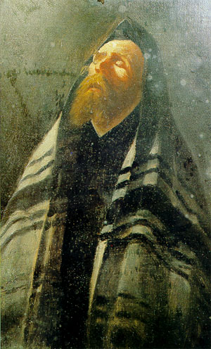
In the blissful winds of silence, the reception of the sacraments had led me to this wayward and mysterious abode.

Despite the wretched winds of worldliness which purported the tides of a greater cause, my soul could not help but feel a certain blissful emanation which was not yet so far distant from the annals of my soul.

Beyond the current of the winds, was a continual vibration which was leading me forward into the clear and still waters of a silent emanation, a silent abode.

Whizzing by beyond the speed of light, my spirit was literally running through the aeons, granting the universal stanza’s of God to depart from my flesh all wayward or organic diametrical opposition.

And then suddenly, my spirit stopped . . .

Before me was a quiet and eternal abode. The light radiated from every pore of what appeared as a transcendent and translucent tabernacle.

It was not physical nor ethereal . . . it was like a sudden manifestation that appears when and where it pleases in its immanence and self producing proclivities.

Instantly, my silent spirit was thrust to its knees as I bowed down in honor before the iridescent throne room of God.

And as quickly as I had bowed, my spirit was transported into the huge vestige that bore no true definition and no intrinsic location. It seemed only that the throne room was revealed to the inner man when the interior sanctuary was ready to observe it.

Within the confines of the throne room, God’s presence was absolutely felt encompassing, overwhelming, embracing and loving my entire spirit. But I could not see an intelligible being, nor did I see a throne. The room was empty sans for a large open window which opened itself to the universal spheres and aeons, although there was an enclosed nature about it.

For hours, I just kneeled and soaked in the energy of God in all his blissful malaise. The light entered into my spirit in a manner unlike any other because it entered in every way, through every sense, through every location of the spiritual body, through every emotion, through every serene thought . . . and it came a strong but steady paternal vibration.

Glazing into the vibration was blissful beyond words. All things seemed very simple here, there was a great deal of compassion from God for all His creation, but it was a completely detached and functional compassion.

The window began to operate with extreme ferocity . . . my soul watched as it began to open up to the many aeons of existence within God’s holy universes and worlds.

And as it did, it was my task to simply emanate. Hundreds of situations appeared. The first one involved a young woman whose heart had been broken, and I began to emanate energy to her from my hands, from my third eye, my crown chakra and from my entire being. As I did so, the energies dissipated from myself and encompassed her with forward moving thrust.

Hundreds of images came across my vision from many periods of time, many places across the universal spheres, from many worlds . . . and I continued to emanate this holy and compassionate energy, but also remained completely detached as I’d observed the energy of the throne room itself in each and every situation, no matter the seriousness of the suffering.

Hours passed as hundreds more situations appeared before me; wars, famines, victims of horrific crimes . . . and as these progressed, the emanations continued to come from myself but they began to expand.

As the situations became more and more brutal, more and more difficult to alter . . . the Lord God allowed me to sweep my arms throughout the throne room and direct the energies from His room directly towards the situations at hand.

The energies in the throne room were now moving very specifically towards those in total despair and the movement of these powerful winds towards those in grave suffering also caused a momentary detachment on their own part . . . allowing for a thrust of knowledge to enter within them; to give them light and peace, and to enable them to receive input and thrust from God Himself to know to whence they should go from here.

It was beyond words, but God had the capacity for true and deep compassion with a form of detachment which allowed for creation to move.

And that’s what I learned from being in the throne room; to emanate with compassion yet detachment in order that the energies you are required to carry and deliver to others may bear fruit.

Although my time in the throne room had lasted many, many hours, I asked the Lord God a total of nine times if He would prolong my stay. And to each question, He answered yes. And thus it was that I stayed in the throne room for twenty eight hours.

Shortly thereafter, my spirit was sent to an old castle wherein remained the remnant souls of many who had committed and been victimized by heinous acts of war and torture. As it was so, the spirits were participating in a satanic ritual within the confines of the castle walls and as I’d entered it was clear that their primary purpose this evening was to take my own life and the lives of my children.

Thus, a battle ensued.

Interestingly, these spirits appeared in the form of a multitude of demons but in ways I had not yet seen. Each of them appeared in some hideous fashion, but entirely different from any other. The marks of their individual and unique sins were born on their demonic bodies.

While one would be reptilian and spindly with horns and reddish features, another would appear huge with a burden on his back, like a huge bag of weight beyond bearing with his face having the tendrils of a combination of a vampiric spirit and the deathly pale of a darkened ghost as his body was very obese yet humanoid.

There were hundreds of them in the castle and it would be impossible to describe them all. But every single one of them had an entirely different appearance. It was quite intimidating and frightening.

As I floated forth into the room, I began the battle with my usual emanations towards them and the battle which now ensued. As usual, the light coming from my spirit destroyed them, and many lie completely immoveable now upon the floor as if dead. Their bodies would then ignite into flame and they would become ashen but not burn entirely of their substantial nature.

But as time passed, although it appeared we were winning the battle, the demonic spirits would slowly recover and resume their nefarious activities. Thus, the war had no potential for an end and these souls remained lost in their evil, for it was an absolute and true evil in which they had chosen to reside.

The Word of the Lord was immediately pressed into my soul to approach two of the demonic figures which had not yet resurrected themselves and to quietly breathe into their noses.

Although this sounds horrific beyond all nature, I was surprised and moved to see that in utilizing the emanation from within my soul to breathe life, so to speak, into their souls had an entirely different effect.

Immediately their faces began turning to a dark blue and very, very slowly an internal light began to forge its way through. Rather than resurrecting into their former demonic selves, these lost and frightened spirits became quiet and stared up towards the Almighty God’s abodes.

Breathing into their noses brought life into them, thus potential, and simply destroying the demonic and evil forces within the souls would not work towards the highest construct which was to seed within them the potentiality of the light and the eternal thrust they would need to pursue it.

These two eventually stood up and went to sit at a table, their eyes completely fixed upwards.

As the other demons continued to attempt to battle, I was led to a few more who were ripe for the influx of the eternal light and I breathed into their nostrils, as well.

And when it was made known to me that I had seeded the ones who could receive of it, my spirit simply disappeared and emanated home.

From Wisdom of the Ages

“Spirit needs neither props nor outside influences to make its mission known to thee. Its throne room is within, and only one can have audience at a time.
Thou must go alone if thou wouldst receive its blessings and commands.
Others cannot hear for thee; others cannot see for thee; others cannot receive for thee.
Spirit never calls two at a time. Its pathway does not admit of two walking abreast.
Through the same ethers and at the same times travel the varied forces of the universe, yet they never interfere with one another. Each is bent on its own mission.
In this world there is plenty of room for all, and there will be no jostling when all find their rightful places.
Yet, even as it is, the self-centred one is never disturbed.
Only those who are trying orbits that belong to others disturb and are disturbed.
Alone thou must be, and yet not alone, for the ethereal currents from interstellar spaces sweep around thee freighted with priceless cargoes.
Influences are about and with thee that know not earth as their home.
From all around thee Nature stretches out her hands encouragingly, and from above all power is showered upon thee.
Indeed, the favors of heaven are thine own, and thine associates kindred spirits from universes unnumbered.
Out of thine own sphere thou art hampered, cramped and besieged by forces, powers and influences that impede thy onward progress.
In thine own sphere thou art the ruler. Even the stars, nebulæ, universes lay their tribute at thy feet.
Indeed, the golden crown, sparkling with jewels, brighter and richer by far than the earth affords, sits gracefully upon the brow of the king who has become the ruler in the sphere of his own self-consciousness.
To him, all winds are alike; all experiences as they should be; all influences good; for all yield unto him a subtle essence that giveth strength and power.
None can bring evil unto him, for his feet walk the shining pathway of the spirit.”
Wisdom of the Ages, George A. Fuller, 1916
CHAPTER TWO
The Rose and How to Deliberate It



Who among us,
Could deliberate the consequence?
The consequence of fools and the wise alike;
The sting of a deed done wrongly
The harboring of a fugitive thought towards a brother?
Only amidst the consequence of ether
Can a soul truly know its peace
For to unduly ring the bell of wisdom
Would require a higher and wiser range of motion
From which most of humanity is slighted
Because of their own neglect
But to whom shall the Emissary turn?
When amidst the toil and confusion
Of an earthly life . . .
The consequential reality of the sin and karma
Past misdeeds
Incorrect thinking
False doctrine
Illusory thoughts
And the simple gasping awareness of the littleness
Of every single soul
Takes a hold of the Emissary
And wakes it to its own weakness
What must it do then?
For of itself it can do nothing.
But what is of great avail to the mystical traveler
Is the knowledge of the wonder of vibration
For it has the power to transform the tiny speck of humankind
Which is the central core of every one of us
And elevate it to a higher consequence
And this is the secret . . .
Of the Emissary

As the seamless horizon had taken hold of my spirit, I watched before me as a scene unforetold to my imagination became manifest before my vision.

A very young St. Padre Pio came towards me in an urgent manner. Looking as if he was now about the age of thirty years, he said something very important was going to happen.

As his words had barely dropped from his lips an explosion in the distance seemed imminent. Somehow, his words had provided enough of a foreshadowing for me to raise my hands and allow the power of the Holy Spirit to come through me and cease the explosion before it took place.

St. Padre Pio looked pleased and then he was gone.

And suddenly, as if my soul were a simple container or wisp of existence, my spirit began a journey unbeknownst to me and of such a caliber that words will not do it justice. For no justice can be borne of it.

Within its confines my spirit was whisked into mystical lands beyond my present comprehension, vibrationary worlds which surpassed all that I had ever seen, and the land of ‘peace’ and ‘all-tranquility.’

In this insanely quiet rapture, my soul lay rapt within the arms of God the Father, God the Son and God the Holy Spirit as the fiery mirth of the winds of spiritual change were swept over me as though by a wisp of breath from each One.

But yet these wisps were as flames which enraptured and consumed everything unlike Themselves within the muse which now held Their sway.

Remaining silent, my spirit was now cloaked in a robe, a garment of a monk to hide my identity. As I walked quietly by those who would wish to speak to me at this time, the silence beckoned me deeper and deeper within the confines of the world of no sound.

Looking down, I hid my face from those who would wish to talk. And I walked by quickly so as to remain unseen as I journeyed ever closer to the Source of these unbegotten wisps of breath.

Within moments, my spirit was now retained again within the throne room of God; filled with the light, the bliss and surrounded in the Presence of the Blessed Sacrament. It was completely silent.

I did not speak or move. I looked . . . and as I looked around me, something wondrous began to happen.

My spirit was taken on a journey through the lifetimes of my family. First, I was to see the past, present and future of my mother and my siblings. Secondly, I was to wander through the future of my children with their spouses and my grandchildren.

These moments were filled with happiness and joy.

And I felt a totally silent peace.

But then a whirlwind began to ascend from the midst of the floor. Again my spirit was whisked through aeons and aeons of time, into many worlds and many realities beyond my comprehension.
The Lord expressed great happiness about the progress I was making on the earthly monastery He had assigned me to create in my own home. It was almost complete, and it was to His liking.

And then ensued hundreds of vibrational raisings to worlds, frequencies, etheric masteries I could never have imagined. Taken into the heights of the vibrational worlds, I realized that I had only just begun to comprehend the mysteries of our Lord and the many mansions of His creation.

Reveling for hour upon hour in this mysterious journey, my spirit was being put through the fiery cleansing of frequency to purify it of all that remained of the dross of the world. And in the end, my soul would emerge gloriously washed in the blood of the lamb. The fire and the cross were the vehicle, the vibrations were the mechanism, and the Lord was the Master.

I gladly submitted to Him.

And the Lord asked me to submit to you this journey within the confines of the Rose, and within the visual spectrum.

Because . . . my spirit began a journey unbeknownst to me and of such a caliber that words will not do it justice. For no justice can be borne of it. And so I speak in images of a journey which no words can bear. View them wisely, for they speak of things which cannot be uttered . . . and within each image lie mysteries of which I cannot speak. Seek them, look for them . . . find them.
THE JOURNEY OF WHICH NO WORDS CAN UTTER


As with all life, the soul (her soul) began within the thorns of the world.
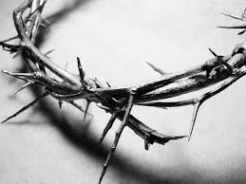
But the thorns were through the Crown of Thorns which Christ bore upon His head.

Every human soul began as a seed, the seed of a red rose.

And the soul (her soul) sprouted . . .

As her little soul grew, it was pruned and eventually prepared to blossom . . .

Before it blossomed, however, it needed to grow into a larger bush.

But eventually, her soul began the process to flower.

And then her soul peeked out just a bit to see what might lie outside of its comfortable enclosure. 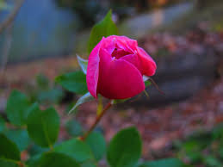
And she saw there was no reason to fear and began to open.
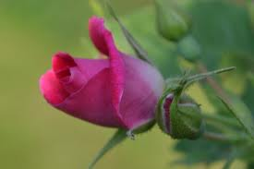
And the freedom she felt compelled it to continue . . .
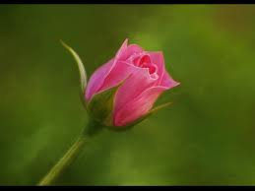
And continue . . .

And then she blossomed into a beautiful new creation.

But her soul looked upon itself and all around and realized there were still thorns.

And as the leaves replenished around the fading blossoms, and life continued to erupt; the thorns remained.
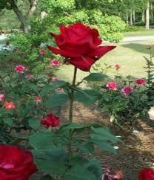
But yet amongst the fiery brush and the thorns, her soul could still erupt in perfection.

And as one soul blossomed, others followed.

And the blossoms joined together in beauty and created an ethereal synergy.

And the soul now contemplated her condition. She covered herself with a cloak, so she could remain in silence for this important and silent looking within.

And the Holy Spirit descended . . .
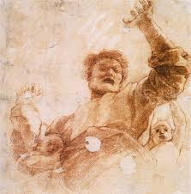
And God the Father emanated to the earth the beginning of new life.

The soul remembered her own birth.

She wept in memory of her sin and karmic stain.
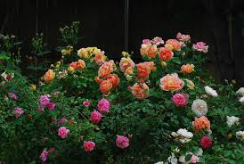
But she remembered that the blossoms must exist . . .

amongst the thorns.
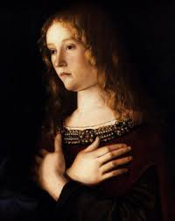
So she contemplated her thorns, she looked upon her own sinfulness.

And the barren wilderness of her past misdeeds overwhelmed her.
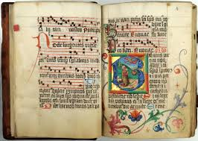
She looked to the great writings of the Prophets, Saints, Mystics, Sages and Ascetics to understand her own sinfulness and the means to overcome that nature.

And a great light descended into her wilderness.

But the roses surrounded the ancient sacred texts and the words lit up as if on fire.

And as the words became fire and the blossoming ensued; the soul threw herself to the feet of Christ. Mercy emanated from His feet.
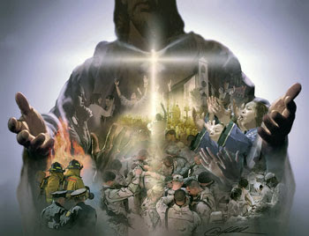
And He showed her the world and all that lay within.

She then saw before her ‘Lady Justice’ and knew that in order to follow Christ, she must allow justice to do its bidding within her. Her sins would have to be weighed out according to her longing for the Lord. And in so doing, she allowed for mercy to become a mechanism within her soul.
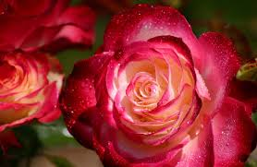
And her repentance and contrition blossomed.
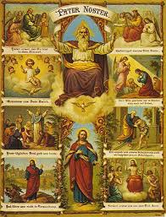
And her learning of the Way came to pass.
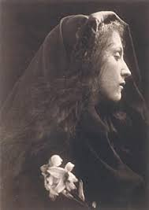
Again she saw herself and knew there was much need for change and transformation within her soul.

But the roses blossomed in her wilderness.

And she saw herself growing up as a young girl surrounded by the blossoms.
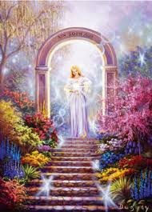
And suddenly, a path awaited her to enter the garden of roses, and angels revealed themselves from their prior concealment.

The roses blossomed and were filled with fertile waters.
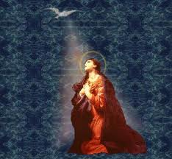
She threw herself to the ground as the Holy Spirit descended to begin her purification.

And the Holy Spirit brought her gifts of sanctification and vibration.
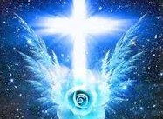
The Cross and the rose blossomed and emanated together.
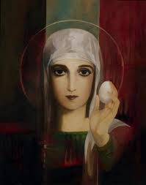
An Emissary brought the Sacred and Holy Eucharist to her soul to aid the purification which was now taking place within her.

Her soul blossomed into a perfect flower.
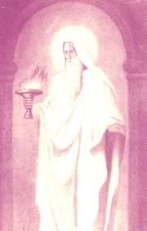
Another Emissary came to bring the fire.
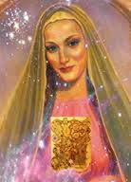
Another Emissary came to bring the sacred and holy texts.

And the blossom became a bouquet

Although light and shadow still remained.

But the frosty waters . . .

adorned the petals of the soul and her individual blossoms.

And the waters purified.

And the soul saw herself in her weakness and looked towards heaven for the remedy.

Light entered her wilderness.
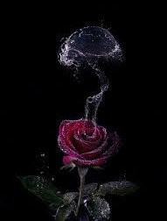
Something began to stir within the soul, within the rose. Was it smoke? Was it the frosty waters beginning to disburse? It was as yet unclear.
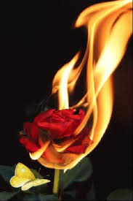
Awwww, the rose ignited into a grand flame!

A gate now stood before the soul, the flower.

The soul (the flower) had burst into flame.

The soul emanated.
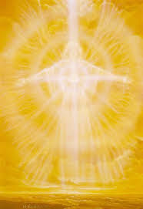
The soul received thrusts of heightened vibration.

It ascended into the soul as a rushing flame of light and ethereal matter.
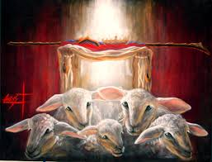
The Tomb was now empty, the Christ had risen and the blood of the lamb had made her soul white as snow.

The purity of the white, the blood of the red; the soul had received both.

And the flame continued to consume her soul, the rose.

The soul received inexplicable thrusts from the eternal spheres of light.

The Holy Spirit descended upon all who will receive of Him.

The eternal spheres started to turn.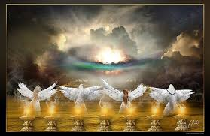
And the angels watched the soul as she received of this heavenly thrust.
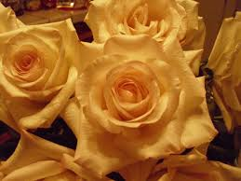
The soul blossomed.
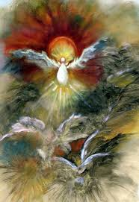
The Holy Spirit filled the blossoms with greater and higher frequencies of vibration.

The rose and the soul began to be consumed by the flame.

The soul reached out to receive the fires of purification.

She erupted into flame and her garments became purified white.

Still lying upon her mystical place of slumber, her wings emerged and she refused to awaken to the world for she knew these thrusts were only the beginning of the journey she must now make.

A heavenly portal opened.

A carriage awaited her . . .

She traveled through galaxies.

And the waters continued to enrich the rose.

She traveled through more portals;
and frequencies beyond bearing.

Geometric universes she couldn’t yet understand disarmed her.

She remained now far from the world.

And her wings and garments of white shimmered in the galactic heavens.

The rose, her soul, was now completely alit in flame.

Whilst her earthly body remained the same, it received and contained within it the fires of purification, the winds of vibration and frequency and the Chalice of the Blessed Sacrament.


She heard the music of the spheres which she could see was being played on a violin with a bow made of a singular red rose aflame with the power of the Holy Spirit.
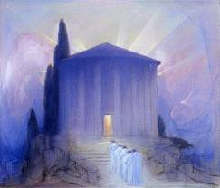
The temple appeared to her soul and she walked slowly with the others to enter.

The world remained distant.

Joining the others in the temple, she allowed them to emanate into her soul the light and vibration of higher thoughts.

And Our Lady of the Roses appeared to assist.
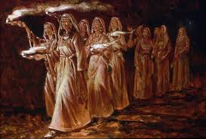
The Emissaries brought their offerings deeper into the temple.
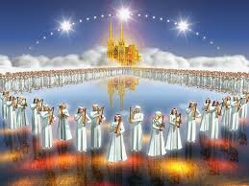
Her soul’s vision was opened and she saw that she was now within a heavenly city guarded by the Emissaries of the light.

An angel brought the DNA pattern to seed within her cellular memory.

And the rose continued to be consumed by the fire of knowledge.

The soul now surrounded by heavenly Emissaries, awakened to the frequencies being emitted into her heart.

The rose continued to be consumed.
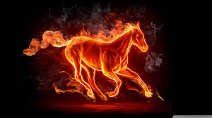
A mysterious enflamed horse appeared.

The rose continued to be consumed.

And suddenly, the fire broke out all around her soul’s physical sphere awaking her for just a moment to the music which was coming from the fire, the wisdom and knowledge which was transforming both her body and soul.

An Emissary brought perfumes and incense.
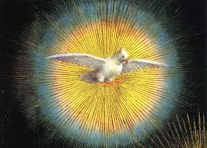
The Holy Spirit continued to amp up the frequency and vibration.

The soul was swept through many aeons and worlds.

For a moment, the soul gazed upon its barrenness without God.

But again, the soul was swept through many aeons and worlds.

And suddenly, the tree which was once dead appeared teeming with life because God was now present.
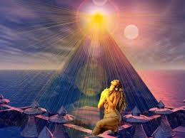
She received of the emanations . . . she received from the aeons.

A sheltered rose garden presented the next path for her soul to take. She walked through the gateway.
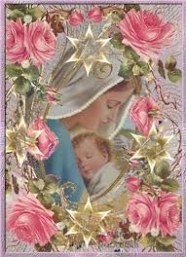
The Blessed Virgin appeared ensconced in Roses. Her soul gazed in awe.

But it just as quickly disappeared as a window into eternity, engraved with fiery roses engulfed in light opening to her yet another portal into worlds beyond her present imaginings.
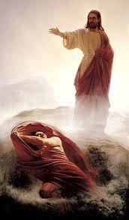
As she threw herself into the portal, she fell to the ground in awareness of her unworthiness to come to this place. But Our Lord appeared and raised His hands to summon her forth.
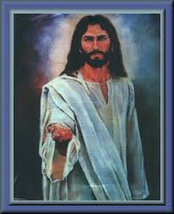
And He reached His hands towards her in welcome.

And the soul’s rose blossomed in a heavenly delight.

She stood now at the gate all in white, like a bride awaiting her bridegroom.

And a great door appeared before the bride and opened slightly to bid her to come in.

And as she entered, she found herself walking in the great waters of purification surrounded in a great light.
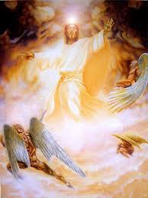
The angels and Our Lord appeared before her to again shed more light and frequency upon her soul.

And she came to dry ground filled with bliss and awe at what she has just seen.

She was presented with a crown.
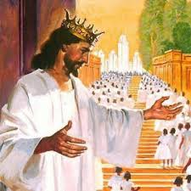
Our Lord bade her to look upon the Eternal City.
And her roses bloomed and blossomed with great beauty.

She was offered a ring.

And a great steed appeared to take her to the next point along her journey.

The horse let her off before a grand staircase into the higher heavens.

She ran with fervor to meet her Master and only true love.

And the diamond light was given to her in abundance.

Her soul reveled in the bliss of the heightening vibration and frequency.

She beheld the Eternal City.
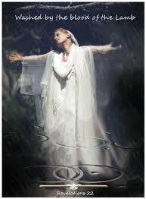
And her soul was declared ‘washed’ in the blood of the Lamb.

A caravan of angels came to greet her and escort her across the great waters.
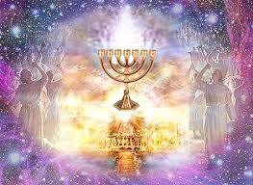
She passed through temple gates, staring in awe.

She was taken to a wonderfully light-filled room to await her betrothal to the Beloved.
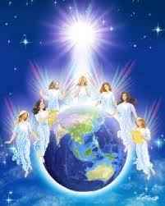
And the angels rejoiced and surrounded the world with their goodness at the impending nuptials.
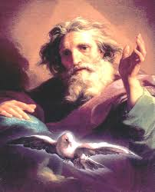
God, the Father, sent His blessings upon her.
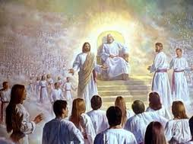
Our Lord accepts His Father’s Blessings, as well.

The Holy Spirit sent His blessings upon her.
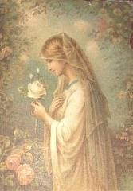
The Blessed Mother showered her with roses.

The soul bloomed inside the frequency.

A further gateway appeared, and she entered.

And there before her stood the great Lion of Judah, Our Lord; the bridegroom to which she was betrothed. And then He disappeared very quickly.

And the skies opened up to reveal yet another portal in the Eternal City to which her gaze became fixed.
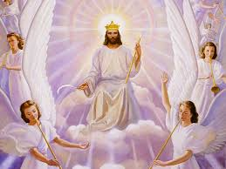
The King of Glory awaited.

The Holy Spirit came to fetch her for the grand nuptials.

And she waited upon the balcony for the great event to take place . . .
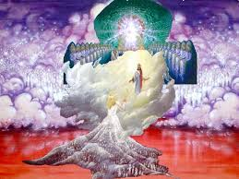
Moments later she stood before her Beloved, as He beckoned her forth.
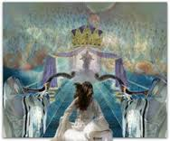
She ran to embrace Him in a fury of love.

But there remained a chasm between her and His city.

She blossomed where she stood.

The light came within her in a flurry of vibration and bliss.

And she became as a pure white rose.
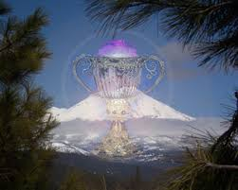
The chalice appeared before her indicating her right to cross the great divide.

Reaching towards it, the light grasped a hold of her and pulled her within the higher sphere.
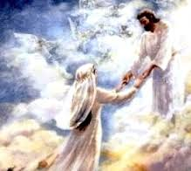
And her Beloved greeted her at her arrival.
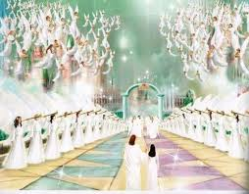
He took her forward to witness the great assembly gathered in honor of this occasion.

And her soul, the rose, was enlivened with the union of the divine and the human, the love of Christ being borne within her heart.

She blossomed.

She blossomed more . . .
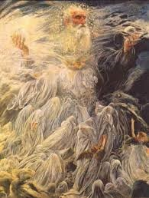
God, the Father, made His Presence known and gathered His blessings upon all those who were to attend.

The Holy Spirit descended and blessed the rose.

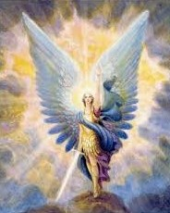
Angels sent forth their light in unison.
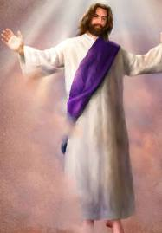
And the Lord descended towards His bride.

Grasping her beloved, her soul (the rose) embraced Him, and in so doing, embraced all that is divine; relinquishing the sinful relics which had once held her to the world.
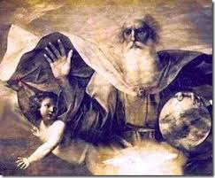
The Father, Son and Holy Spirit blessed the union.

Her soul received the blessing in the form of vibration, frequency and light; a shudder of ecstatic peace.

When this blessing had consumed her, she sat in wait of the grand moment to come as her Beloved remained with her in spirit and in truth.

Preparing for yet another journey higher, she traveled upwards through worlds to come upon her final destination.
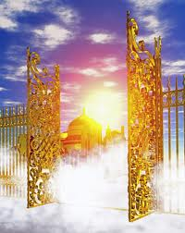
Golden gates opened for her arrival.
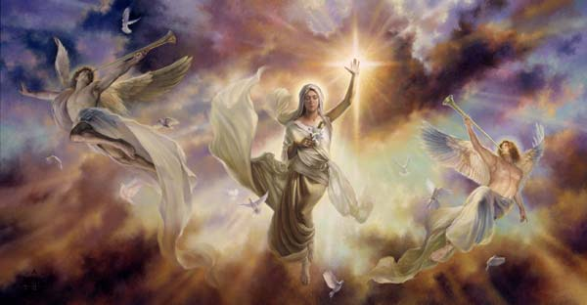
As she entered, angels congregated in celebration.
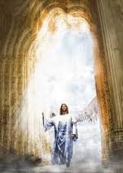
Her Lord and Beloved entered.

She entered.
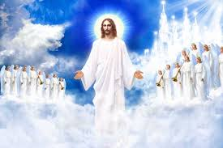
Her Lord, watched by many angels, proceeded forth to the throne.
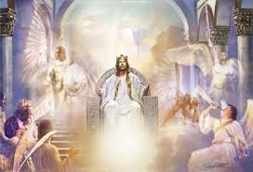
And thereupon, He was crowned and awaited the ceremonial occasion.
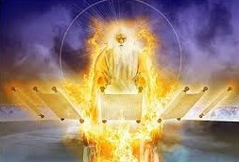
As God, the Father, broke out all the scrolls to permit their blessings to be showered upon her and the union to come.
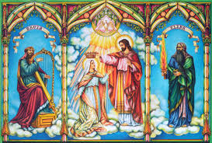
Our Lord crowned His mother.

Our Lord energized and crowned His bride in a fury of light.

A union occurred in these crownings. The two Mary’s, the Blessed Virgin and the Magdalene became one and proceeded to create a fertile blossoming within the rose (her soul.)

Her soul gazed upon the eternal city.
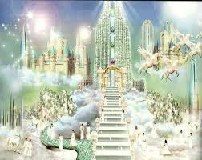
It was beautiful and filled with light.

Technology existed here that she had not seen in the world.

And an enriched splendor in the natural world was evident in the heavenly abode.

Again, the soul was given to look upon the world.

She was given to look upon the rose.

Her soul was swept into a swirling lightfield of knowledge and wisdom:

and galaxies and galaxies of energetic thrust.
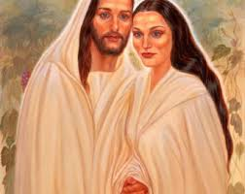
She emerged as a unity. Divinity and humanity, her Beloved and she, were one. But only a few moments would be afforded her during this grand eclipse.

Those who bore witness began walking away from the scene of the uniting.

Her Beloved departed in a flurry of light, leaving her emanating a wondrous glow.

But as suddenly as she was wafted away from the world, she was suddenly returned. An angel bids her adieu.
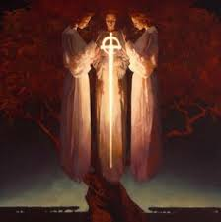
The Seraphim gathered and united in prayer for her journey below.

She received the light from their prayers.

And as suddenly as they had come, the angels turned to leave her in the world and return to their heavenly station.

Before her she saw the Lord’s hands beckoning her to remain at the Holy Banquet, although she must return to her earthly abode.

For a moment, she remembered their union in the heavenly spheres. And He embraced her one more time in a frenzy of frequency, vibration, emanation and light

She was given the gift of the white and red rose, the blood and the purity.

She exited into the earthly sphere through a garden gate.

And shed her ethereal body in her journey to the earthly realm.

She awakened again on earth surrounded by a singularly beautiful, huge and emanating rose. The Holy Spirit remained for a moment to ensure her safe passage.
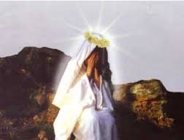
As she realized the departure of her Beloved, she mourned His loss on earth, although she remained aware of their unity in spirit.
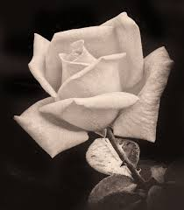
A singular pure white rose fell from the sky as a gift from the heavens.

The Holy Spirit again confirmed her in her Divine Union, and she bowed in humility.

But the departure of the Holy Spirit caused the soul to rise. Raising her head and hands to the sky, she called out a prayer of thanksgiving to Our Lord.

Without warning, she was inexplicably showered in red roses which came directly from the heights of the eternal sky entering within her and around her from the heavens to the earth below.

And then she was completely covered in the red roses, and appeared to be no more.

But yet, a pure and single white rose was borne of the shower of red roses.

Her purity was thusly maintained by a singular decision. In so choosing to follow the Lord and Saviour Jesus Christ and accepting the fiery process of purification; only a singular and purely white rose remained. Not of her own merit; but only because of mercy freely chosen was this gift given to her.

Although her sins were so many as to completely obscure her presence beneath them, the grace of the blood made present in the shower of red roses was easily overcome in purity as borne by the singular white rose.

And thus it was so . . . it was in this manner that the Emissary was borne in her soul and the flowering of frequency culminated into God’s grand design.

“What brings you here?”
The Good Lord asked
“To maintain the frequency of the spheres
To bargain with the finer spheres for my redemption
To offer myself as reparation for myself
To hand over my free will to the Will of the Almighty God
And to give of myself until I am no more.”
She answered.
His smile was upon her.
And thus it became so.

CHAPTER THREE
Truth is not Relative, there is Objective Truth



My peace comes with wonder and awe
There is a balance between the two worlds
Truth is not relative
There is objective truth
Energetic action both good and evil
Nothing but the finger of the angels can incorrupt this
The worlds of light and life
Choose aggressive boundaries
Duality allows imbalance,
Indecision and tampered thinking
No other name
No other name
Achieves frequential dignity
The line between right and wrong is delineated clearly by vibration
There is no ardor here
Wisps of memory confound all truth
There is no ally greater than truth
But it must be achieved by generation
As a principle
We must not simply generate kindness
We must generate truth
In worlds of form, truth is not always received well
Good is perceived as evil and evil, good
But there is no path aside from truth for the Emissary
There is only one Way upward
The Emissary MUST take that Way
By so doing, he/she emanates
By so doing, he/she continues to ascend
By so doing, he/she generates wisdom
Although chaos may appear to be the result
For the truth does not always generate peace
In a dualistic world
Truth can generate unrest in the souls of the unjust
The uncultivated souls become disturbed when the vibration of truth enters their spheres
Change is difficult for uncultivated souls
Truth is difficult to see for such as these
But kindness alone, mercy alone . . .
Will not bring souls higher frequential capacity
Truth will
So the Emissary emanates only the truth
And by so doing, allows the Holy Spirit to work with those who receive of it
In other words
The Emissary must only allow that which is forward and upward
Kindness and mercy which allow backwards flow
Do not permit evolution to be incumbent upon a soul
In fact, such allows retention and acceleration of backwards flow
Truth is consequential
In that it obfuscates forward movement
Falsehood is inconsequential
In that it retains a backwards flow
The Emissary must only emanate the truth
No matter how difficult the frequential collaboration this may present
And . . . this is the secret of the Emissary

The elements of darkness which are retained within every dualistic human soul are infinite and hidden to the mortal view. It is only from the heights of eternal glory that they may be discerned wisely, correctly and with the knowledge required to alter and contain divine wisdom.

That which we generate within our own lives of delusion and destruction may be completely obscured by the very nature of our belief thus paralyzing us to remain within the continual circling within the misunderstanding which guides us.

Truth is not relative. There is objective truth. And the Emissary moves within this knowledge.

My daughter, Mary was taken deeply into the bowels of our past. Within them she was shown the point wherein the dark side had begun their efforts to destroy our family through the witchcraft and dark affiliations of other people. She followed this line of darkness up until the present day wherein she saw the current beholder of the dark sword of malevolence directed towards us.

The dark side had used people who were vulnerable to their suggestions, who practiced witchcraft and who were just easy containers for such intentions. And this had begun nearly thirty years prior.

Our family had been plagued with difficulties; many of them apparently of our own making. Both Andy and I held responsibility for various aspects of the destruction. But we had not realized how intensively the dark side wished to destroy our family, to destroy families in general and how much energy was exerted by the dark side and its forces to make this happen in our lives and the lives of others.

A complete onslaught of energies was again focused on the destruction of our family, and Mary was told to pray. And these were the prayers we prayed to ward off the darkness as much as we could.

Our Father
Who Art in Heaven
Hallowed be Thy Name
Thy Kingdom Come
Thy Will Be Done
On Earth as it is in Heaven
Give us this Day Our Daily Bread
And Forgive us Our Trespasses
As we Forgive Those who have Trespassed Against Us
And Lead us not into Temptation
But Deliver us from Evil
For Thine is the Kingdom, The Power and the Glory,
Forever and Ever, Amen

Hail Mary, Full of Grace, the Lord is With Thee
Blessed Art Thou Amongst Women
And Blessed is the Fruit of Thy Womb Jesus
Holy Mary, Mother of God
Pray for Us Sinners
Now and at the Hour of Our Death
Amen

St. Michael, the Archangel
Defend Us in Battle
Be Our Defense Against the Wickedness and Snares of the Devil
May Rebuke Him we Humbly Pray
And Do Thou Oh Prince of the Heavenly Host
By the Divine Power of God
Thrust into Hell Satan and All the Other Evil Spirits
Who Prowl About the World Seeking the Ruin of Souls.
Amen.

My husband, Andy, was taken deeply into the bowels of my past. Within them he was shown the moment that a particular demon had been given entry unto my soul through an act of foul violence. Again, thirty years prior . . .

Lying unconscious in my vehicle, I was about to be raped. At that time, I had gone to a restaurant/bar and had dinner and someone had put the date rape drug into my drink. Despite this, Andy was shown that somehow I had agreed to this even on a soul level. Perhaps it was even the choices I had been making which led to the places I would go, the things I would do . . . etc.

Just a few feet away from the rapist, he saw a tall and very dark black demon. It emanated great power and extremely destructive views of love which would be implanted the moment that the rapist was to penetrate.

In my current waking life, he had accomplished that feat.

But in my husband’s journey into the past, he had a new objective. That past was going to be altered.

The moment that the demon so anxiously waited for was about to happen, but Andy swooped in and grabbed me out of the car.

It was as if that moment had never happened. The demon was unable to enter, he had altered the past.

By so doing, he had altered my inability to get past my own destructive views of love.

Once identified, the demon could no longer affect you. Elusive and sinister; this demon’s power was in those qualities and the fact that the recipient did not even know he was there.

And then my soul was given to such delight, I could not properly nor amiably describe.

Sitting in a waiting area for a very special guest, I knew that I had entered the abode wherein A.C. Bhaktivedanta Swami Prabhupada now resides.

He was coming to see me on an elevator and I couldn’t wait to meet him.

Getting up as I heard the elevator ding, I walked towards the doors and awaited his eminent arrival.

When the doors opened, Swami Prabhupada appeared with three of his assistants.

Bowing to kiss his hand, he allowed me to do so even though he behaved as though I was being silly. “I never thought I would have an opportunity to meet you.” I said. “I have most of your books.”
Walking me back to the sitting area, he emanated such loving kindness and happiness in getting to meet me, as well. We sat down facing one another.

Placing his hands in mine, his energy became quite direct.

Holding my hands before him, he said, “There are many things that went terribly wrong in your life. But you must look at what you have done to generate them.”

And then he was gone . . .

It took me several days to pray, contemplate and ponder on his words before I was able to realize how I had actually been generating such things.

In my belief system, it seemed that kindness demanded of me to never hold anyone accountable for the harm that they did. Because of this, I often avoided those persons, situations, places of those who had done such things. Often, I didn’t even acknowledge the wrong done. In other words, I let people completely off the hook. (I had never pressed charges against the rapist.)

Refusing to hold others accountable allows them to twist reality and thus, the truth. By so doing, somehow the responsibility for their action comes down upon their victim rather than themselves.

Thus, when no responsibility for their action comes down upon them, they are actually energized to perpetuate more evil as the natural consequences of their actions have not been activated.

But energetic law demands something different. The frequential vibration of the heights cannot be dragged down into the continual circling of the dualities.

In essence, kindness demanded that my energy be withdrawn from such situations and that those perpetuating such things would then by of necessity bounce back towards their own compatibility and be held accountable for their actions.

Rather than drawing me into their duality, I had to ascend into the transcendent eternal One.

Suddenly, I was walking with a friend towards my home. As we were coming upon the house of someone who had done grave harm to me, I said to her, “I know it’s really out of the way, but we should probably walk around.”

The eminent and Blessed Virgin Mary appeared in the sky and vehemently denied my request. Firstly, she instructed me to no longer ignore or deny it when others violated my life through any means. “You stand for the truth, and I will stand with you.” She said.

And then she insisted we walk forward.

We did not change our route to avoid the home of this person who had done grave harm and had tried with great precision to place responsibility for that harm upon my own soul.

We looked at the path before us and were instantly enchanted by the footsteps which were etched in the ground before us.

Within them were images of the Blessed Virgin Mary and the holy angels were hovering about at her feet.

From St. Padre Pio

“Always stay close to the Heavenly Mother because she is the sea to be crossed to reach the shores of Eternal Splendor.”

St. Padre Pio

And we stood for the truth, walked forward, hid nothing; and we avoided no person, place or thing which would seek to make good evil, and evil good.

I had done nothing wrong in such circumstances. It was not my place to take responsibility for them.

We walked forward confidently in the steps of the Most Holy Mother Mary. Because . . .

Kindness and mercy which allow backwards flow
Do not permit evolution to be incumbent upon a soul
In fact, such allows retention and acceleration of backwards flow
Truth is consequential
In that it obfuscates forward movement
Falsehood is inconsequential
In that it retains a backwards flow
The Emissary must only emanate the truth
No matter how difficult the frequential collaboration this may present
And . . . this is the secret of the Emissary

From Solid Virtue

“God frequently punishes the abuse of sufficient grace by the subtraction of such as efficacious.

Now, of all the chastisements He could inflict this is the most dire, the most just, and the most ordinary.

- The subtraction of grace is the most terrible chastisement of its abuse. There is no greater misfortune, nor anything so much to be dreaded as that which tends to alienate us from God, the Sovereign Good, and to subject us to the sovereign evil – sin and hell . . . By a special ordinance of the Almighty this grace is so absolutely necessary for the working out of our salvation, that without it, it would be equally impossible for us to possess God or to escape hell. It is true that we could be saved with purely sufficient grace, but, accustomed as we are to an unworthy resistance to it, and weakened by these very infidelities, we are in imminent danger of continuing in this road of perdition . . . The subtraction of grace is, I repeat, the direst penalty of its abuse. Let us appeal to the judgment of the truly wise, those enlightened and guided by faith, and we shall learn that there can be no more awful punishment than that which tends to render the sinner more obdurate in his guilt, blinds his understanding so far as to prevent his discerning his danger, captivates his will so as to divest it of the power of even desiring to break its fetters, deprives him of the best means of doing penance, and levels and abridges the path to vice. And yet, such are the bitter fruits of the privation of the interior lights and inspirations of efficacious grace. When the Almighty allows us to suffer opprobrium, persecution, sickness, etc., it is a punishment, it is true; but it is not unmitigated, since in these instances His only object is to wean us from sin and attach us to Himself. In inflicting these trials He acts not as a judge but as a father who, in the chastisement of sin, proposes to himself the conversion of the sinner . . .
- The subtraction of grace is, on the part of God, an equitable vengeance exercised by Him against the sinner. Grace is the pledge of the love of the heavenly Bridegroom who remains at the door of your heart, knocking, entreating, tenderly imploring admittance. But you do not hearken to His voice, you turn a deaf ear to His pleadings, you refuse Him entrance. Tired of knowing and finding Himself despised, He at length ceases. His importunities, He retires. What could be more just? A Grace is a burning and shining light with which God desires to enlighten your mind and inflame your heart; but you close the eyes of your soul, you seek darkness, and like the wild owl you shun light and warmth. The Sun of Justice, finding you constantly rebellious to His divine influences, at length withdraws His rays. He ceases to shine for you. What could be more just? Grace is an inestimable treasure, a pearl of the crown of Jesus Christ, the Pledge of eternal life.”

Solid Virtue, Rev. Father Bellecius, S.J., Christ the King Library

From a Manual of Ascetical Theology

“We have seen from the definition of the Council of Vienne . . . that a created intellect needs the Light of Glory to see God intuitively, as the blessed see Him in heaven. The reason of this is because a faculty that of itself and intrinsically is incapable of a certain act, in order to elicit that act needs to be intrinsically elevated, strengthened and perfected by some power received into itself for this purpose. But the created intellect is intrinsically incapable of seeing God intuitively, and therefore to elicit this vision it must be elevated, strengthened and perfected by some further power received into itself. This power which is imparted to the created intellect to enable it to elicit the vision of God is called the Light of Glory, because it has the same relation to the Beatific Vision as corporal light has to the eye in order to see its object.

The Light of Glory is not God Himself, because it must be something received into the intellect, informing it and inhering in it for the purpose of intrinsically strengthening it and making it proportionate to its object; and God cannot be said to be thus received into the created mind. Neither is this Light of Glory either the simultaneous or actual concursus or motion of God, as this does not impart to the faculty any intrinsic power, but supposes that power there already ; or if it be supposed to impart any intrinsic power to strengthen and elevate the mind to see God, that would be its effect, and it would add something intrinsically to the will, which is what we want, and what we call the Light of Glory, and this could not be said to be the concursus itself.

The Light of Glory in the blessed is a permanent quality or a supernatural infused habit inhering in the intellect, elevating and strengthening it to see God. The reason assigned for calling it a habit or infused quality is because a faculty acts more easily and more connaturally by a permanent form than by a passing or transient help, as this is more in accordance with the natural mode of acting. Hence, as habitual charity is given in heaven to love God, so a habitual light is given to see Him. Although the Council of Vienne has defined it as of faith that the Light of Glory is necessary to see God, it has not, however, defined that this Light of Glory is a habit or quality.

The Light of Glory has three offices, as it were, to discharge. The first and principal one is to elevate the intellect to elicit the Beatific Vision. The second is to dispose the intellect for the reception of the Divine Essence as an intelligible form.

The third is to dispose the intellect for the reception of the Beatific Vision itself, because as the Beatific Vision is an action immanent — that is, not passing out of the agent — it follows that, as the Light of Glory disposes the intellect to elicit this vision, it also disposes it to receive it.

I find the following explanation of the Light of Glory well given and illustrated in a small manual, explanation the Light entitled 'The Happiness of Heaven, by Rev. F. J. Boudreaux, S.J.: ' Theologians define the Light of Glory to be " a supernatural intellectual power infused into the soul, by which she is enabled to see God, which she could never do by her own unassisted natural power." It is called supernatural because it is not a natural talent or power of our nature, as the talent for poetry, music, painting, and others, all of which may be developed and highly improved by study. But the Light of Glory is an elevation, expansion or development of the mind, which comes directly from God, and is in no sense the result of human endeavours, except in so far as it has been deserved by a holy life. We shall understand better the meaning of the Light of Glory by an illustration.

Let us suppose that you never could learn mathematics or astronomy. In spite of the most intense application, you never could master even the multiplication table; and when you gazed upon the heavens you could never see there any more beauty and magnificence than does the untutored savage.

But on a sudden there is a flash of light from above, and your mind is enlightened far beyond its natural capacity, and you can see all the heavenly bodies as they are. You can now know their names, motions, distances, laws, and relations to each other and to the whole universe. Formerly they appeared all alike, except the sun and the moon; but now you see that no two of them are alike. Each one has its own size, velocity, beauty and glory. You even soar far beyond the discoveries of science, and you gaze with delight upon millions of shining worlds which the most powerful telescope never did and never can reach. You can, moreover, in the twinkling of an eye, calculate with astonishing precision the day, the hour, the minute, the year, the very second, at which an eclipse will occur. Gazing upon the heavens, which hitherto had given you so little satisfaction, now becomes the source of the most exquisite and rational pleasure. For you now see in these countless worlds so much beauty and magnificence, so delightful a harmony, that you can spend whole nights in the contemplation of the heavens.
This sudden elevation and expansion of your mind to see such wonders in the natural order illustrates what takes place in heaven the moment a pure soul enters there. In the supposition just made you receive an accession or addition of intellectual power, which enables you to see clearly and to understand what was invisible and unintelligible to you before the flash enlightened you. The Light of Glory produces a similar effect upon the soul at her entrance into heaven.

Our mind, which is now unable to see God, except as through a glass in a dark manner, is suddenly elevated in power to see God as He is, face to face, and to contemplate His Divine beauty and His other perfections, Our individual mind is neither destroyed nor changed into another ; it is only strengthened and elevated in power and capacity far beyond anything we could ever have reached by our own unassisted endeavours . . . So, then, the Light of Glory is a supernatural addition to our mind, which enables us to cross the gulf between the Creator and the creature. I say gulf, because no created intelligence can see God as He is by its own natural power. Hence, neither St. Augustine, nor St. Thomas, nor any other giant intellect, could see God as He is in Himself, any better than the man who never could learn his letters. It is in this sense that we must understand St. Paul when, speaking of God, he says: Who alone hath immortality, and inhabiteth light inaccessible; Whom no man hath seen, nor can see. Evidently he means that no one can see God by the light of nature; for in another place he tells us that when that which is perfect is come we shall see Him face to face.'

Concerning the Light of Glory a question arises as to the manner in which this light and man's intellect concur in the act of the Beatific Vision. The answer is that both concur actively, as is well shown by Billuart, who treats very fully this whole subject. The Light of Glory concurs actively, because it holds the same relation to the Beatific Vision as charity to beatific love, and all the other supernatural habits to their supernatural acts. Now, charity as well as the other supernatural habits concur actively to the supernatural acts which they enable the soul to elicit, inasmuch as they dispose, perfect and elevate the faculties to make them capable of such acts. In like manner the Light of Glory concurs actively in respect to the Beatific Vision. The intellect also concurs actively to this vision, because the Beatific Vision is a vital act of the blessed— yea, it is their very life — and therefore it should proceed effectively from a vital power intrinsic to the beatified soul, and moving itself vitally by its own intrinsic force, namely, by the intellect, so that the intellect does not produce the Beatific Vision merely as an instrument, but as the principal agent, as it moves itself vitally in the way just mentioned. The intellect, therefore, and the Light of Glory concur as two total causes in the act of vision, each in its own order, the Light of Glory as the total proximate and formal cause by which the intellect is elevated and proportioned to the act of vision, the intellect as the total principle eliciting the vision, in the same manner as the will and the virtue of charity have themselves in respect to the love of God.

The Light of Glory is the physical cause of the inequality of the Beatific Vision; so that it may be said that the whole inequality comes physically from the inequality of the Light of Glory, and not from the intellect. Thus, in the case of two of the blessed in heaven, one of whom may have a much brighter and keener intellect than the other, if they receive an equal Light of Glory they will see God equally; or the one whose intelligence is weaker naturally may have a far more perfect vision of God by reason of the greater Light of Glory which is bestowed on account of his holier life.

From all this it follows that all men are on a footing of perfect equality so far as the power of seeing God is concerned. No one has that power in himself by nature, and no one can give it to himself or develop it by study, as we can other powers we have received in the natural order. . . .

I have been particular,' says Father Boudreaux, ' in explaining and insisting upon these things, lest it might be imagined that men of highly-cultivated minds, such as philosophers, theologians, poets, and the like, shall see God better and enjoy more of heaven's happiness than the ignorant, in virtue of their superior natural gifts. They certainly shall Not. God does not bestow a supernatural reward upon the natural gifts, or even upon the natural virtues . . . But He does reward the faith, hope, charity, and other virtues which His children have practised in this world. Hence, theologians teach that not even the Angels, who are so superior to us, see God any better in virtue of their nobler and more perfect intellect. Thus, supposing an Angel and a man to be equal in merit, they both receive the same amount of Light of Glory; they both see God in the same degree of perfection, and both, therefore, enjoy the same degree of happiness. . . .

Hence, the man who never learned his letters, either from want of natural talent or opportunity, shall undoubtedly see God as well as the philosopher, if he has led as good a life; and he shall see Him better and enjoy more of heaven's happiness if he has lived a holier life. . . .

Once more: The light of glory is a supernatural elevation of the mind which enables man to see God as He is in Himself. It is given by God Himself to those who have lived a supernatural life of faith, hope and charity. Moreover, it is given to each in proportion to his personal merits. It therefore becomes the measure of the degree of happiness which each one of the blessed enjoys in the vision of God.' (Happiness of Heaven,' chap. xiii.)

A Manual of Ascetical Theology: The Supernatural Life of the Soul on Earth and in Heaven, Rev. Arthur Devine, 1901

CHAPTER FOUR
The Mechanism of the Light of Glory



Afloat upon the wings of Majesty
The soul tarries to the higher shore
In its midst
Remain the remnants of earthly dualities
But not within
For within there is new unity
An encompassing oneness
An embracing light
An effulgent bliss
Beyond these shores
The Emissary can no longer retain individuality
Nor does she wish to do so
As the sequential flopping of her arms embraces
The exit of all that remains within
They flop at her side
Like a flower dizzied by the sun
Or unquenched by the waters
But what is this that is happening?
An emptying?
A perusal of sorts?
The gaze of the Emissary becomes fixed
For there is nothing to see unless God so deigns it
Beyond the shores of the Solitary
The Emissary releases her shine
Her glory is no more
She falls limp to the ground
In an organic display of relinquishment
For to whom has she been seeking?
Not herself
No, not the self
But the God of the self
And in order to embrace that union of all unions
She must become nothing
And so she wilts into the ground
Like a flower who is dying
Like a blossom which decays
Like a rose on the last leg of its journey into full bloom
And she waits
For there is no more
The Emissary has nothing to seek
Nothing to find
Nothing to embrace
Nothing to foreshadow
Nothing to dismiss
Nothing to gain
Nothing to lose
Only the Light of Glory holds her interest now
But of what essence this is
She does not know
Of what manner or power
She does not know
Of what substance
No knowledge
She awaits her Beloved
Limp
Completely emptied but not forlorn
There is a bliss in nothing
There is an ecstasy in being unfilled
All movement ceases within her
And thus . . . movement now begins
And this is the secret of the Emissary

And so, in her ignorance, the Emissary was borne out of her existence upon this earth and taken into a world anew beyond any previous splendor she could have known, foreseen or imagined.

Met at the shore by two future saints, it was given to know them as such even though they had not yet been canonized. Their holy magnificence humbled her as she fell to her knees in gratitude for their coming. But they took her hand and lifted her up, leading and guiding her spirit into a sacred interior tabernacle beyond all spectacle of imagining.

Looking around, she could not speak, for there were no words. Within her she felt the distinctive essence of the Presence of God which was disbursed in every molecular transcription of this grand and infinite space.

Only that which was holy could enter here, and she did not feel herself worthy. So she stood in awe and silence as her spirit was given by an external force to slowly turn around and look upon the entirety of this body and essence of the spirit of God.

She was rapt in her attentions, and she said nothing. Her eyes were like that of a child looking up to a beloved and spectacular parent for whom such love was borne that it was beyond imagining.

From Gregory of Valence

“It is to be stated that the empyreal heaven is a certain celestial orb above all the others, immovable, most bright, all beautiful and perfect in itself, the abode of the blessed souls where God manifests Himself clearly to their intuitive vision.”

Gregory of Valence
In this space, it was impossible to regard the self as an ‘I;’ for it was a ‘she’ now who was experiencing and watching . . . not herself.

But I bowed before my two saintly guardians again and announced my unworthiness to be in such a place.

One of the guardians stepped forward and said:

From Solanus Casey

“We must be faithful to the present moment or we will frustrate the plan of God for our lives . . . God condescends to use our powers if we don’t spoil His plans by ours.”

Solanus Casey

And the other followed:

From the Secret of Sanctity

“We are induced to love God by the knowledge which faith gives; but when we have begun to love His infinite goodness, love increases our natural tendency thereto, as this inclination reciprocally augments love.”

The Secret of Sanctity, St. Francis de Sales, Fr Crasset, S.J.

And I continued to kneel before them.

Suddenly, a wind began to swirl around me like a typhoon of power beyond all earthly conception. It was so powerful, I became overwhelmed and begged to understand what was happening to me.

It was given for me to know interiorly how God had made me worthy to enter here and beyond this, what the Almighty was now in the process of doing for my soul.

From Christian Holiness

“The decisions of the moral life and of holiness itself are taken in the final analysis by one’s own personal conscience. It is this conscience that we must refine and make more delicate and submit as much as possible to the action of the good spirit, as well as making it as strong and as resistant as possible to attacks from the evil spirit. That is why the more we succeed in developing a certain docility towards God, the easier will the choice become because we will be more sensitive to the action of the Holy Spirit. But the less our life is habitually pliable and submitted to God, the less will we be sensitive to and apt to seek these slightest signs of the divine will or call. Christians anxious for spiritual progress ought to refine their conscience supernaturally . . . “

Christian Holiness, A Precis of Ascetical theology, Gustave Thils, Lannoo Publishers, 1963

From Pope Benedict the XVI

“God is not solitude, but perfect communion. For this reason the human person, the image of God, realizes himself or herself in love, which is a sincere gift of self.”

Pope Benedict XVI

The guardians stood in quiet as the circling winds began to progress into higher and higher frequencies of power all around my spirit and a very large crucifix appeared before me in this cosmic space and all became as water. My spirit fell before the altar as a sacrifice in the crucifixion pose, with my arms held out to and my face to the ground.

And within just a few seconds, this wind of God entered into my spiritual body and overtook my soul. What was to follow was so beyond words and my own ability to explain, but it has been beckoned to me to try.

The power of God had come upon me. Every part of me was now in His complete and profound control. Nothing of me remained. If for a moment, this power were to cease, my external faculties ceased.

He animated my spiritual body and began to use me in ways I could never fathom. It was as if through this power that He has come into me, he had transformed me into some kind of angelic vessel.

It began slowly, but then proceeded to happen very quickly as my spiritual body was taken from this empyrean heaven back to the abodes of the earth to work with hundreds of souls in need of energetic adjustments of revelations within their lives.

Through no will or knowledge of my own, God’s power was exerted through my eyes in the form of lights; my hands in the form of energetic movement and through my entirety of being in the form of truths which were not my own but belonged entirely to God.

For instance, for those who needed to find something that had been given to them years earlier, my hands were used to move and manipulate those items and make them appear in a place more suitable for those souls to find the objects which had a certain intention for the welfare, awakening and spiritual progress of that individual.

For those engaged in false doctrines, lights came from my eyes or my hands and switched what they were seeing to the grand truth of the Holy Catholic Church and the centrality of Jesus Christ.

I was shown beyond any words I could utter, the absolute truth and finality of the Holy Roman Catholic Church. I will never be able to utter how it was shown to me, but it was show in an infinite way the truths of the faith and the errors of other paths.

It was not that these paths led to damnation, nor that God was not merciful to those who did not yet know, but He did allow me to change the spectacled vision of those were wading in such false doctrines to the central vision of Christ Our Lord.

Hundreds of souls were being altered by the emanation of light, relics of the saints appeared before me and I knew they were important, my body and hands went limp and everything moved through me rather than by me. I suffered from an inexplicable thirst.

“The Lord has spoken and He has charged me with good things.” I said. “You have shown me where Your true mystery lies.” Grace was helping so many people who would never know it.

The two guardians walked by and slapped my hand with grace, literally slapped it . . . “Keep the reminder of Christ always before your eyes.” They said.

Soothsayers, tarot card readers, new age, mormonism, divination . . . all containing error. The soothsayers and diviners were sent spinning on a wheel to thrust the untruths from inside of them to the exterior.

Remember, all of these were sincere and ready for an instant alteration . . . the fact that they were in error was not something held against them, but rather, their sincerity and readiness for the truth was what had brought this about.

People were watching television and it was filled with falsehoods, the light changed the television to an image of Christ.

A woman was led to a 75-year old ring which was going to play a part in her awakening, and a man with a horrible illness was raised from the dead.

It was inexplicable, and beyond anything I could ever say. I know beyond faith or reason, that the Holy Catholic Church is true. And my mission with God was to seed that truth in others who might be misled at this time.

And my soul remained in a state of rapture throughout the many hours for which the Lord took hold of my spirit and soul.

Many souls were struggling with personal issues, and my body was utilized to then move things, energies and bodies of knowledge to seed within them the solution to their disturbance or affliction.

From the Graces of Interior Prayer,

“I said farther back that the full plenitude of the understanding is retained during the rapture; it even seems to be enlarged and that there is a growth of activity in the higher faculties. All ecstatics confirm this fact, which stands out in all that they tell us concerning the mysteries that have been revealed to them. Magnificent sights, profound ideas present themselves to the mind. They are powerless to explain in detail what they have seen, however. This is not because the intelligence has been as it were asleep, but because it has been raised to truths which are beyond the strength of the human understanding, and they have no terms by which to give expression to them.

As Fr. De Bonniot remarks: ‘It is not enough to say that the language which is adapted to the ordinary operations of the human mind is necessarily insufficient; the ideas themselves, those ideas by which we understand everything, because they are the basis of our judgements, are no longer applicable to the intuitions of ecstasy which are of an infinitely higher order. (Le miracle et ses contrefacons.)’”

The Graces of Interior Prayer, A Poulain, SJ

For a moment, God ceased . . . perhaps just to allow me and the spirits around me to observe what happened thereafter. At the moment God ceased, my spiritual body fell limp, my arms prostrated to the ground and my eyes lost their glimmer and focus.

Without God’s presence within me, I was a limp and helpless child; no foreknowledge or vision came from myself.

As God continued to allow me to alter literally hundreds of soul’s paths, I was able to observe the knowledgelessness that bore the signs of my existence. Without his power and focus, I knew not what these souls needed. But within seconds, God’s vision would direct my spiritual body towards the exact remedy for each and every individual soul.

Sometimes the remedies were surprising to me, at other times, they were more clear.

Love
Light
Emanation
Evaluation
Evolution
Energetic Alteration
Evermore
Everywhere

And again, He would cease and I would go limp . . . as limp as any lifeless body. But quickly, He would again seize my spirit to reach out towards yet another soul in need of alteration towards a higher thrust. It was as if my spiritual body had passed beyond the natural confines of the human soul into that of an angelic emissary of some kind. Inexplicable, it was . . .

From the Extract on the Celestial Hierarchy

“What we said about the angelic orders is rightly perceived to concern all divine minds. Just as the superior minds have virtues and knowledge that the inferiors have, but in a more abundant way, so in turn do the inferiors participate and share in the virtue and knowledge of the higher orders, not equally but in a lower way. Therefore, it is not unsuitable that our hierarch in sacred scripture is called an ‘angel.’ According to his virtue, our human hierarch participates in the virtue of ‘announcing,’ which is, to be sure, the peculiar quality of angels. Having acquired the property of angels, our hierarch teaches men to imitate the various manifestations of angels in a divine and celestial way.

It is found as well that sacred scripture calls ‘gods’ not only certain celestial powers, but also men of special holiness and excellence most beloved of God,’ although the divine substance in itself is superessentially separated and elevated above all things and from all communion with things. No existing being is comparable with God in any way whatsoever. Yet every celestial and human mind that according to its virtues is converted back to a unifying communion of the one, and that according to its possibility is incomprehensibly expanded toward the divine illuminations (insofar as it is able), is worthy [of the title] through imitation of God and by means of a divine equivocation.”

Thomas Gallos, Extract on the Celestial Hierarchy, 1246

But as I continued to allow the Divine Presence to work within my spiritual body, there was a twofold theme radiating throughout each and every one of these situations for which God had called me in to assist. 1.) That every soul, regardless of their own current faith, was seeking God sincerely, and 2.) Every soul was ready for a significant revelation to enter their life at this very moment. This was not in the abode of a time sequential, as each alteration occurred and manifested on the ground simultaneously, instantly. And these souls had prepared for such a triune grace . . .

From Spiritual Guidance

“Jesus said: ‘If anyone wishes to come after Me, let him deny himself, and take his cross daily, and follow Me. ‘ We deny ourselves when, by a sincere conversion, we turn away from our former vices – for instance, by becoming temperate and restraining ourselves from whatever is licentious. ‘We abandon ourselves,’ says St. Gregory,’ when we avoid what we were of old and try to attain that to which we are called by our new birth.’ To deny ourselves, according to the doctrine of Christ, is to have no will of our own, to despise ourselves, to condemn our lives when necessary for the sake of Christ, to renounce our attachments and desires. It means avoiding what self-love suggests to us, but pursuing the prescriptions of divine will. It implies that we are not to seek ourselves but God, that we to avoid and banish whatever is opposed to the law of God, and put aside worldly and carnal desires and affections. In a word, negation signifies rejection and repudiation of anything, even if it is pleasant and agreeable, that is not in perfect agreement with the will of God.”

Spiritual Guidance: Fundamentals of Ascetical Theology, By Adolph Kestens, O.F.M. Cap. And Elmer Stoffel, OF.M. Cap., St. Anthony’s Guild, 1962

Each alteration was like a revolution within my spirit, and with each revolution, my ecstatic joy and happiness attained to an even greater height. It was as if I was experiencing the beatific vision as God moved through me and by me . . . interiorly, there was an intrinsic knowledge of God’s absolute and unconditional love for myself and all those souls who seek Him with sincerity.

From the Endowments of Man

“That one soul whom we have considered as she has reached the final object of her existence is but an example from the great multitude which no endowments of man can number, and in whom are exhibited the Man inexhaustible diversities of the Divine gifts. Each of them has a separate and singular history; each has her own course among the countless works that mark the ways of souls through time; each her own path of providence; each her own luminous chain of graces and mercies that have conducted her in a different way from nothingness to the final possession of God. And when all these souls shall have received their corporal frames anew, raised in the power of Christ from mortality to immortality, and from dishonour to glory, each will be the spiritualized and agile instrument of the soul to which it belongs, having its own proper character and glory, derived from the glorifying presence of God in the soul. The great end of creation, contemplated from the first, is accomplished in them. God is wonderful in His Saints. Their very bodies are as harps and cymbals on which to celebrate the praises of God, Who has raised earth itself to a life so magnificent. The kingdom of Christ is transformed into the kingdom of heaven, where He reigns supreme over those whom He has purchased with His Blood and perfected by His Spirit. It is the new heaven and the new earth raised up to God by Him Who makes all things new. And whilst every spirit praises God with a gratitude ever renewed for all that He has done for her, that endless diversity of spirits in
whom one Spirit reigns gives an inconceivable breadth and magnificence to the harmony of the celestial choirs, in whom all the works of the Lord bless the Lord, praise and exalt Him for evermore.”
The Endowments of Man, Bishop Ullathorne
It was equally clear to my spirit that this love of God had come from nothing of myself that I possessed, but what I had allowed God to possess of me.

Within this, I instantly knew the secret of the Emissary. It contained within it the consistent dispelling of the personal will to the higher thrust of knowledge. And in this, the continual correspondence of the body and soul to Christ, Our Lord, and the surrender of the will in a special way to God’s will with each and every decision muted towards virtue.
From Solid Virtue

“A soul devoted to virtue dispels itself of its own will, no longer to follow any will but that of God. It voluntarily renounces the esteem of men and the gratification of the senses; its only wish is to desire nothing; its only ambition to possess an absolute empire over self. As nothing happens with the permission of God, and as the holy soul wishes nothing but what God wishes, so nothing can occur contrary to its desires. It thirsts for contempt, loves its own affliction; there contempt cannot disturb or adversity deject it. It desires nothing, or at least very little; it desires and perceives without eagerness; so that, come what may, its peace of heart is never compromised. It consequently enjoys a pure and unalterable interior joy incomprehensible to those who have not experienced it.

Can virtuous souls be otherwise happy? They have placed their felicity in the imperishable Being, their trust in Him who is immortal, and their confidence in the Infallible: they therefore necessarily enjoy true delights, they are established in solid happiness, and, like the inhabitants of heaven, raised above all human vicissitudes, they live in constant serenity. If there is any happiness on earth it is the inheritance of a soul which labours zealously for its sanctification. And yet, who would believe it? the greater number of men hear these truths without being moved by them, without experiencing any pious emotion; they meditate upon them without being inflamed with a love of virtue; they deem it too difficult to ‘crop off the twigs of the cedar to take away the marrow’ (Ezekiel xvii 4), ‘to go up into the palm tree to take hold of the fruit thereof, (Canticles vii 8), to refuse the fleshpots of Egypt, in order to feed upon the celestial manna. O heavens! We believe that ‘a soul’ zealous for its sanctification is a ‘perpetual banquet’ (Proverbs xv 15), and yet like the prodigal child, we prefer to live in the society of unclean animals, to feed on their disgusting food rather than aspire to the delicious nutriment granted to virtue. Lord, ‘enlighten my darkness,’ (Psalms xvii 29) inspire me with an utter abhorrence of earthly things, and an ardent desire for those of heaven.”

Solid Virtue, Rev. Father Bellecius, S.J.

The inbreath and the outbreath of God continued to move through me, let me go, move through me, let me go, move through me, let me go, move through me let me go . . . there was no end to the delights of evolution in progress. My rapture was complete, there was no greater ecstasy, no greater vision I had ever attained to than this moment.

Ever forward, ever ceasing . . . the beatific vision remained clearly before me and within me in a way which I will never be able to explain or express to another.

From the Catechism of the Council of Trent

“The enumeration of all the delights with which the
glory of the blessed shall be replete would be endless, nor can we even imagine them in thought. Of this, however, the faithful should be persuaded, that the blessed life of those in heaven overflows with the abundance of all those things that can be agree able to us, or even desired in this life, whether they pertain to mental knowledge or to bodily perfection, although this the Apostle affirms to be accomplished in a manner more exalted than eye hath seen, or ear heard, or than hath entered into the heart of man.

For the body, indeed, which before was gross and material, having put off mortality, and being refined
and made spiritual in heaven, will no longer stand in
need of nutriment; whilst the soul will, in the supreme delight, be satiated with that eternal food of glory which the Master of that great feast, passing, will minister unto all. And who can desire rich garments or royal robes where there shall be no use for these things, and all shall be clothed with immortality and splendour, and adorned with a crown of imperishable glory? And if the possession of a spacious and magnificent mansion pertains to human happiness, what more spacious, what more magnificent, can be conceived than heaven itself illumined, as it is throughout, with the brightness of God? Hence the prophet, contemplating the beauty of this dwelling-place, and burning with the desire of reaching those blessed abodes, exclaims: How lovely are Thy tabernacles, O Lord of Hosts! My soul longeth and fainteth for the courts of the Lord: my heart and my flesh have rejoiced in the living God.''

The Catechism of the Council of Trent

Continuing to bask in the glory of God, I could wish for nothing except that this never end . . .

From Lessius

Speaking of the three acts which constitute the Beatific Vision, Lessius says:

”In these three acts resides God's chiefest glory, which He Himself intended in all His works ; and so, likewise, in these acts reside the highest good and formal beatitude of men and Angels. By these acts the blessed spirits are vastly elevated above themselves, and, in their union with God, become Godlike by a most lofty and supereminent similitude with God, so that the mind can conceive no greater. Thus, like very gods, they shine to all eternity in the Divine brightness. By these same acts they expand themselves into immensity, so as to be co-equal and co-extensive, so far as may be, to so great a good, that they may take it in and comprehend it at all. They linger not outside, as it were, upon the surface of it; but they go down to its profound depths, and enter into the joy of their Lord, some more, some less, according to the magnitude of the Light of Glory imparted to each. Immersed in this abyss, they lose themselves and all created things; for all other good and joys seem to them as nothing by the side of this ocean of good and joys. In this abyss there is to them no darkness, no obscurity, such as now hangs over us, regarding the Divinity; but all is light and immense serenity. There are there eternal mansions with a tranquil serenity that they can never fail. There is the fulfilling of all their desires. There is the possession and enjoyment of all things that are desirable. There nothing will remain to be longed for, or sought for any more, for all will firmly possess and exquisitely enjoy every good thing in God. There the occupation of the Saints will be to contemplate the infinite beauty of God, to love His infinite goodness, to enjoy His infinite sweetness, to be filled to overflowing with the torrent of His pleasures, and to exult with an unspeakable delight in His infinite glory, and in all the good things which He and they possess. Hence come perpetual praise and benediction and thanksgiving; and thus the blessed, having reached the consummation of all their desires, and knowing not what more to crave, rest in God as their last end.”

The Theologian, Lessius

Encompassed by these beatific lights, not for one moment did my rapture cease. But my spirit was brought within a cluster of stars where this beatitude expanded and multiplied into a greater substance, consubstantial with the Father. And it was in this moment, that my spirit was escalated to a realm of knowledge which contained within it a science and a mysticism, combined as if a unity.
It became known to me that the mystical rapture in which my spirit was encompassed was the height of scientific mystery.
From Albert Einstein
"Science without religion is lame, religion without science is blind." Albert Einstein

It also became known to me that the Emissary, thus the full and potent nature of the soul, could not come into existence without first entering into the knowledge of good and evil. For as the world fell because of Eve’s desire to know it; the world could only rise through the individual spirit of humanity chastising itself by traveling through its mystery.

From Albert Einstein
“The world is a dangerous place to live; not because of the people who are evil, but because of the people who don't do anything about it . . . God did not create evil. Just as darkness is the absence of light, evil is the absence of God.”
Albert Einstein

From the Holy Bible
"What I am doing is sending you out like sheep among wolves. You must be clever as snakes and innocent as doves. Be on your guard with respect to others . . . You will be hated by all on account of me . . . If they call the head of the house Beelzebub, how much more the members of his household! Do not let them intimidate you. Nothing is concealed that will not be revealed, and nothing hidden that will not become known. What I tell you in darkness, speak in the light." The Holy Bible, Words of Christ, Matthew 10:16 – 27
"Therefore take unto you the armour of God, that you may be able to resist in the evil day, and to stand in all things perfect. Stand therefore, having your loins girt about with truth, and having on the breast-plate of justice, and your feet shod with the preparation of the gospel of peace: In all things taking the shield of faith, wherewith you may be able to extinguish all the fiery darts of the most wicked one. And take unto you the helmet of salvation, and the sword of the Spirit (which is the word of God)." The Holy Bible, Words of St. Paul, Ephesians 6:13-17

The Holy Bible

From Gracian’s Manual

"Know what is evil, no matter how worshipped it may be. Let the man of sense not mistake it, even when clothed in brocade, or at times crowned in gold, because it cannot thereby hide its hypocrisy, for slavery does not lose its infamy, however noble the master."

Balthazar Gracian y Morales, Gracian's Manual

From Marcus Aurelius

"God overrules all mutinous accidents, brings them under his laws of fate, and makes them all serviceable to his purpose."

Marcus Aurelius

And as the music of the spheres encompassed and filled my spirit with continual delight the word came to me that the scientific community would do well to inquire into the world of the mystic, as the greatest heights of mystery lie within it, and the greatest knowledge of science will not be revealed without it.

From Albert Einstein

""To what extent are you influenced by Christianity?"
"As a child I received instruction both in the Bible and in the Talmud. I am a Jew, but I am enthralled by the luminous figure of the Nazarene."
"Have you read Emil Ludwig’s book on Jesus?"
"Emil Ludwig’s Jesus is shallow. Jesus is too colossal for the pen of phrasemongers, however artful. No man can dispose of Christianity with a bon mot!"
"You accept the historical existence of Jesus?"
"Unquestionably! No one can read the Gospels without feeling the actual presence of Jesus. His personality pulsates in every word. No myth is filled with such life."" Saturday Evening Post, 1929
"If one purges the Judaism of the Prophets and Christianity as Jesus Christ taught it of all subsequent additions, especially those of the priests, one is left with a teaching which is capable of curing all the social ills of humanity. It is the duty of every man of good will to strive steadfastly in his own little world to make this teaching of pure humanity a living force, so far as he can. If he makes an honest attempt in this direction without being crushed and trampled underfoot by his contemporaries, he may consider himself and the community to which he belongs lucky."
"Then there are the fanatical atheists whose intolerance is the same as that of the religious fanatics, and it springs from the same source . . . They are creatures who can't hear the music of the spheres."
"The most beautiful thing we can experience is the mysterious. It is the source of all true art and all science. He to whom this emotion is a stranger, who can no longer pause to wonder and stand rapt in awe, is as good as dead: his eyes are closed."
Albert Einstein
The artful exchange between my spirit and the spheres was coming to a close. I could not bear leaving this, my beatific abode behind. But to everything there is a season and a time amongst the stars . . . and when the Emissary is called to the return, well, that is another mystery of the Emissary.
From the Exercises of St. Gertrude

“And now my soul languisheth and fainteth by reason of the weariness of this life . . . my one longing desire is . . . to offer thee the homage of my song of gladness in unison with that happy company who sing thy praises eternally in the heavens. There, on the altar of thy divine heart, will burn the incense that thou lovest, the incense of my heart’s love and praise, which I shall gladly offer thee in return for all the favours with which thou, my Father and my Master, hast consoled me in all my tribulation and anguish here below.”

The Exercises of St. Gertrude
And that mystery speaks of the beatific vision to which the Emissary is called and the return of the spirit to bring that which is of heaven to earth and the endless journey of the spirit to the finality of which it must never attain. For the finality can never be . . . or else the soul withers and dies. Movement occurs only when movement ceases, and herein lies the beatific vision.
And this is the Secret of the Emissary.

From a Manual of Ascetical Theology

“THE ESSENTIAL OBJECT OF THE BEATIFIC VISION AND ITS ACTS

The object of the Beatific Vision is twofold: one, primary, which is seen by itself and on its own account, and this is God Himself; the other, secondary, which is seen by reason of the primary, and this is creatures. By reason of this twofold object theologians divide the happiness of heaven into essential and accidental. By essential is meant the happiness which the soul receives immediately from God in the Beatific Vision. By accidental is meant the additional pleasure and joys which come to the blessed from creatures. ‘Thus, when our Blessed Lord says, There shall be joy in heaven upon one sinner doing penance, He evidently means a new joy, which the blessed did not possess until sorrow for sin entered the sinner's heart. They were already happy in the Beatific Vision, and would not have lost the least degree of their blessedness, even if that sinner had never repented of his sins. Still, they experience a new joy in his conversion, because therein they see God glorified; and, moreover, they have reason to look for an additional brother or sister to share their bliss. Yet, although the blessed do rejoice in the conversion of the sinner, they do so in virtue of the Beatific Vision, without which they could receive no additional pleasure from creatures. Therefore the Beatific Vision (or the Vision of God) is not only the essential happiness of heaven, but it is also that which imparts to the Saints the power of appropriating all the other inferior joys wherewith God completes the blessedness of His children.'

We have to confine ourselves in this chapter to the consideration of the primary object of the Beatific Vision, from which results the essential happiness of heaven. This object may be considered in itself and in its possession. Considered in itself it is called objective beatitude, and in its possession by the blessed it is called subjective beatitude, or beatitude as it formally exists in the souls of the blessed in heaven.

The essential objective beatitude is God alone. He is the one object that suffices and is required to make man supremely happy. This statement may be proved from the Book of Ecclesiastes, the drift of which is to establish this truth. After setting forth its main proposition in the words, Vanity of vanities, and all is vanity, it concludes as follows : Let us all hear together the conclusion of the discourse, Fear God and keep His commandments : for this is all man. And all things that are done, God will bring into judgment for every error, whether it be good or evil? Therefore, from these inspired words we may conclude that all created things cannot make man happy, and that the one sole business of man is, by keeping the Divine commandments, to secure a favourable judgment before God. To those who receive at the hands of God a favourable judgment, no other reward than God Himself is promised, as expressed in the words of the Lord to Abraham: I am thy protector and thy reward exceeding great. Hence Christ our Lord teaches us: Now this is eternal life: that they may know Thee, the only true God, and Jesus Christ Whom Thou hast sent. Eternal life in Scriptural language is the same as beatitude; therefore beatitude consists in the intellectual possession of God, which has its beginning in this life by faith in Jesus Christ, and is perfected in the future life. Since, therefore, the possession of God is alone our happiness; St. John admonishes us by the words, Love not the world, nor the things that are in the world? Because whatever things are in the world cannot make us happy, and their absence or loss cannot deprive us of that which is our true happiness. One thing is necessary, namely, the possession of God. Still more, the possession of the good things of this life are often a great obstacle to attaining beatitude, according to the teaching laid down in St. Matthew’s Gospel: For he that will save his life, shall lose it; and he that shall lose his life for My sake, shall find it. For what doth it profit a man if he gain the whole world and suffer the loss of his own soul? Or what exchange shall a man give for his soul? And Christ has said on the one hand, Woe to ye rich, and on the other, Blessed are the poor. Truly, then, God, and God only, is the Alpha and Omega, the Beginning and the End.

I need only refer to the definition of Benedict XII. in further proof of this doctrine, as I have already quoted it more than once. It is 'that the blessed enjoy the Essence of God, and that through such vision and fruition the souls of those who have departed are truly blessed and have eternal life and rest; as will also be the souls of those who shall hereafter depart this life.'

According to the dictates of reason, we can conclude the same truth that God, and God alone, is the essential objective happiness of man. The natural desire of happiness which is inborn in the soul ought to be satisfied. No created good can satisfy that desire; therefore its object must be the uncreated good. That such a desire ought to be satisfied is proved from the fact that it would be against the truth, the sanctity, and the goodness of God to implant such a desire in the human soul without making provision for its adequate satisfaction. Created goods cannot certainly satisfy that desire, because the soul has a boundless and undying capacity for happiness, and all created things are transitory, or at least finite. As this reasoning belongs to natural ethics, it need not be further developed in this place, as the simple reference to it, in stating the line of argument, is sufficient to bring home to the mind its own experience with regard to the happiness to be obtained or expected from creatures.

When it is said that God, and God alone, is the essential objective beatitude of the soul, we have to consider what is included in this assertion. Beatitude
means the Essence of God, and all that is formally and necessary contained in that Essence. It means Holy Trinity, and generally all the attributes of God, both the absolute and relative attributes, for the attributes are in reality not distinguished from the Divine Essence, but only in our imperfect way of apprehending them here below. Then, since God, as He is in Himself, is the object of beatitude, the whole Divine perfection, without any distinction, will be the object of beatitude. God, as the object of beatitude, is the supreme intelligible truth and the supreme lovable good. And this is not according to any special perfection, but according to the whole Divine perfection, including all the Divine attributes. It may also be added, with regard to the Holy Trinity, that the Persons in the Trinity are not really distinct from the Divine Essence ; therefore he who sees the Divine Essence in itself must see also the Persons, and he who sees one Person of the Trinity must see the Essence of God, and therefore also the other Persons.

The blessed in heaven, as we have already fully explained, will see God as He is, face to face. And this
means that we shall see Him in all His adorable perfections, by a clear and unclouded perception of His Divine Essence. We shall gaze with unspeakable
delight and rapture upon that beauty, ever ancient and ever new. We shall drink in all knowledge at its Living Source, unmingled with error or doubt. All the darkness and ignorance caused by sin will for ever vanish in the light of God's countenance, as the darkness of night disappears before the rising sun.

‘We shall then see as it is the august and awful mystery of the Most Holy Trinity, the deepest, the sublimest, and the most incomprehensible of all those
that God ever revealed to man. We shall see the Eternal Father, ever begetting His only Son, and the Holy Ghost, ever proceeding from both Father and Son. We shall then see how they are really three distinct Persons and yet one undivided Essence. We shall see face to face, and as He is, this great Eternal God, in the eternity of His duration, in the abysses of His mercies, in the spotlessness of His sanctity, in the severity of His justice, in the might of His irresistible power, in the charms of His captivating beauty, and in the splendour of His majesty and glory. In a word, we shall no longer see God as He is reflected in the mirror of creation, but as He is in Himself.' This extract describes God as the essential object of the Beatific Vision — God in His Essence, in His Persons, three and one — and in His perfections or attributes.

As God is a good distinct from us, and nothing or distinct from us can make us blessed or happy unless
in some way it be united to us, it follows that some union between God and ourselves is necessary to render us happy. This union is effected by the possession of God in heaven, which may be called formal beatitude. I may here notice a mistaken notion about heaven, and correct it in the words of the author already quoted (Rev. Father J. Boudreaux) : ' Some imagine that the vision of God will so completely absorb and monopolize every faculty of man that practically he will become motionless and in
active as a statue. There can be no greater mistake. It is true that our union with God in the Beatific Vision is happiness and joy greater than mortal man can conceive, but it by no means follows that it will hinder the free exercise of our mental faculties or the activities of our glorified bodies; indeed, the very reverse will take place, for glory does not destroy nature, but perfects it.

We are active by nature; action, therefore, both of mind and body, is a law of our being which cannot be changed without radically changing, or, rather, destroying, our whole nature. As glory perfects our whole nature instead of destroying it, it follows that in heaven we shall be far more active than we can possibly be here below, for there all powers will exist in their perfection. Therefore the intellect, elevated and strengthened by the Light of Glory, will continue to think and to contemplate the truth, for such is the natural action of the intellect. Thus also the will, which is the loving power of the soul, shall continue for ever to love, for its natural action is to love the good, the beautiful, and the perfect. The memory also will for ever recall the many graces received from God, thus keeping alive a deep sense of gratitude for His benefits, while the imagination will still continue to make to itself new and captivating pictures of beauty.' This leads up to the propositions that beatitude consists in operation, and that for formal beatitude are required the three acts of vision, love, and joy or happiness. Since beatitude consists in operation, we have to examine what those vital acts are by which beatitude is constituted. In the first place, beatitude cannot consist in any transient or passing act, because as to God we shall not have a passing or transient act in heaven. For beatitude perfects its subject — namely, the beatified soul — and a passing or transient for formal beatitude.

Operations as such do not effect this — at least, not in any permanent way. Then, beatitude is not an operation of the sensitive part of man, because this does not reach or attain the Supreme Good, which is
entirely spiritual. Therefore beatitude is an operation spiritual and immanent— that is, remaining within the agent who elicits it.”

A Manual of Ascetical Theology: The Supernatural Life of the Soul on Earth and in Heaven, Rev. Arthur Devine, 1901

SOURCES

Mysteries of John, Charles Fillmore, 1946
Golden Verses of Pythagorus, Fabre’ de’Olivet, 1917

Socrates

Samyutta Nikaya, John Ireland, 1981
Wisdom of the Ages, George A. Fuller, 1916

Various Public Domain Sources

Solid Virtue, Rev. Father Bellecius, S.J., Christ the King Library

A Manual of Ascetical Theology: The Supernatural Life of the Soul on Earth and in Heaven, Rev. Arthur Devine, 1901

The Catechism of the Council of Trent

Gregory of Valence

The Endowments of Man, Bishop Ullathorne

The Exercises of St. Gertrude

Spiritual Guidance: Fundamentals of Ascetical Theology, By Adolph Kestens, O.F.M. Cap. And Elmer Stoffel, OF.M. Cap., St. Anthony’s Guild, 1962
The Graces of Interior Prayer, A Poulain, SJ

Christian Holiness, A Precis of Ascetical theology, Gustave Thils, Lannoo Publishers, 1963

Solid Virtue, Rev. Father Bellecius, S.J.
The Secret of Sanctity, St. Francis de Sales, Fr Crasset, S.J.

Thomas Gallos, Extract on the Celestial Hierarchy, 1246

Fr. Solanus Casey

Pope Benedict XVI

The Holy Bible

Albert Einstein

Balthazar Gracian y Morales, Gracian's Manual

Marcus Aurelius
The EMISSARY
Sister Silence as Sacrament
By Marilynn Hughes
An Out-of-Body Travel Book
The Out-of-Body Travel Foundation!
http://outofbodytravel.org

THE EMISSARY (An Out-of-Body Travel Book): Sister Silence as Sacrament, always be with me. Follow the journey of the mystic and out-of-body traveler as she enters into the confines of silence. For wherein silence lives, transformation illumines and shakes. In the energies of complete stillness, power and evolutionary thrust are born, shed, and alleviated upon the human sentience of mankind. Follow this path and discover the power within the silence, disregard the noise and move forward into the throne room of God which bends, manipulates and orders evolution in every aspect of life through absolute stillness and abiding quiet. Movement occurs only when movement ceases. (For more info – http://outofbodytravel.org)

